

**Developed by :-**

**Sourav jaiswal &**

**Ankit torani**

Under the Guidance of:

MR. Devendra singh Charan

PGT (Comp.S)

**Submitted by :-**

**Sourav jaiswal Roll no.:- 1724068**

**Ankit torani Roll no.:- 1724067**

#### **Theater**

#### **booking**

#### **system**

A Project Report on : -

**Kendriya Vidyalaya**

**NEPANAGAR**

**dsfdsfs**

**CERTIFICATE**

This is to certify that the Project / Dissertation entitled **THEATRE BOOKING SYSTEM** is a bonafide work done by Master SOURAV JAISWAL & ANKIT TORANI of class XII Session 2017-18 in partial fulfillment of CBSE’s AISSCE Examination 2018 and has been carried out under my direct supervision and guidance. This report or a similar report on the topic has not been submitted for any other examination and does not form a part of any other course undergone by the candidate.

## *……………………………..*

## *Signature of Teacher/Guide*

**Name:** MR. DEVENDRA SINGH CHARAN

**Designation: PGT (CS)**

**Developed by : SOURAV JAISWAL &** ANKIT TORANI

**……….…………………**

### Signature of Principal

**Place: K.V.NEPANAGAR**

**Date:……………..**

**ACKNOWLEDGEMENT**

W

E undertook this Project work, as the part of our XII-Informatics Practices course. We had tried to apply our best of knowledge and experience, gained during the study and class work experience. However, developing software system is generally a quite complex and time-consuming process. It requires a systematic study, insight vision and professional approach during the design and development. Moreover, the developer always feels the need, the help and good wishes of the people near you, who have considerable experience and idea.

We would like to extend our sincere thanks and gratitude to our teacher MR. DEVENDRA SINGH CHARAN .We are very much thankful to our Principal **MR.A.K.SINGH** for giving valuable time and moral support to develop this software.

We would like to take the opportunity to extend our sincere thanks and gratitude to our parents for being a source of inspiration and providing time and freedom to develop this software project.

SOURAV JAISWAL

ANKIT TORANI

**Class XII**

**C O N T E N T S**

1**. Introduction** 1

2. Objective & Scope of the Project 2

**3. Theoretical Background** 4

**4. Problem Definition & Analysis** 16

**5. System Implementation** 22

6.1 The Hardware used: 22

6.2 The Softwares used: 22

**6. System Design & Development** 23

7.2 Database Design: 24

7.3 Menu Design: 34

7.4 I/O Forms Design & Event Coding: 36

**7. User Manual** 150

8.1 How to install: 151

8.2 Working with Software: 152

**8. References**  173

**1. Introduction**

This software project is developed to automate the functionalities of a Theatre Booking System.The purpose of the software project is to develop the Management Information System (MIS) to automate the record keeping of Movies Details, Ticket Details, Screen Details and Bill Amount with Final Receipt with a view to enhance the decision making of the functionaries.

A MIS mainly consists of a computerized database, a collection of inter-related tables for a particular subject or purpose, capable to produce different reports relevant to the user. An application program is tied with the database for easy access and interface to the database. Using Application program or front-end, we can store, retrieve and manage all information in proper way.

users, This software, being simple in design and working, does not require much of training to and can be used as a powerful tool for automating a Ticket Booking System of a Theatre.

During coding and design of the software Project, Java NetBeans IDE, a powerful front-end tool is used for getting Graphical User Interface (GUI) based integrated platform and coding simplicity. As a back-end a powerful, open source RDBMS, My SQL is used as per requirement of the CBSE curriculum of Informatics Practices Course.

**2. Objective & Scope of the Project**

T

he objective of the software project is to develop a computerized MIS to automate the functions of a Ticket Booking System. This software project is also aimed to enhance the current Booking system, which will help managers to retrieve the up-to-date information at right time in right shape.

The proposed software system is expected to do the following functionality-

* To provide a user friendly and Graphical User Interface (GUI).
* The proposed system should maintain all the records and transactions, and should generate the required reports and information when required.
* To provide graphical and user-friendly interface to interact with a centralized database based on client-server architecture.
* To identify the critical operation procedure and possibilities of simplification using modern IT tools and practices.

In its current scope, the software enables user to retrieve and update the information from centralized database designed with MySQL . This software does not require much training time of the users due to limited functionality and simplicity.

During the development of Theatre Booking System project, Java NetBeans IDE, a powerful, open source event-driven form-based development environment is used for modular design and future expandability of the system.

Despite of the best effort of the developer, the following limitations and functional boundaries are visible, which limits the scope of this application software.

1. This software can store records and produce reports in pre-designed format in soft copy. There is no facility yet to produce customized reports. Only specified reports are covered.
2. There is no provision to calculate extra charges like popcorn , colddrinks etc. etc. for defaulter members; however it can be developed easily with the help of adding modules.

So far as future scope of the project is concerned, firstly it is open to any modular expansion i.e. other modules or functions can be designed and embedded to handle the user need in future. Any part of the software and reports can be modified independently without much effort.

**3. Theoretical Background**

## 3.1 What is Database?

### **Introduction and Concepts:**

A database is a collection of information related to a particular subject or purpose, such as tracking customer orders or maintaining a music collection. Using any RDBMS application software like MS SQL Server, MySQL, Oracle, Sybase etc, you can manage all your information from a single database file. Within the file, divide your data into separate storage containers called tables. You may and retrieve the data using queries.

A table is a collection of data about a specific topic, such as products or suppliers. Using a separate table for each topic means you can store that data only once, which makes your database more efficient and reduces data-entry errors. Table organises data into columns (called fields) and rows (called records).

A Primary key is one or more fields whose value or values uniquely identify each record in a table. In a relationship, a primary key is used to refer to specific record in one table from another table. A primary key is called foreign key when it is referred to from another table.

To find and retrieve just the data that meets conditions you specify, including data from multiple tables, create a query. A query can also update or delete multiple records at the same time, and perform built-in or custom calculations on your data.

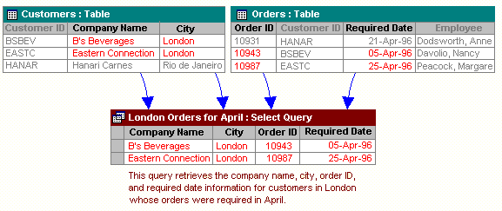

### **Role of RDBMS Application Program:**

A computer database works as a electronic filing system, which has a large number of ways of cross-referencing, and this allows the user many different ways in which to re-organize and retrieve data. A database can handle business inventory, accounting and filing and use the information in its files to prepare summaries, estimates and other reports. The management of data in a database system is done by means of a general-purpose software package called a Database Management System (DBMS). Some commercially available DBMS are MS SQL Server, MS ACCESS, INGRES, ORACLE, and Sybase. A database management system, therefore, is a combination of hardware and software that can be used to set up and monitor a database, and can manage the updating and retrieval of database that has been stored in it. Most of the database management systems have the following capabilities:

* Creating of a table, addition, deletion, modification of records.
* Retrieving data collectively or selectively.
* The data stored can be sorted or indexed at the user's discretion and direction.
* Various reports can be produced from the system. These may be either standardized report or that may be specifically generated according to specific user definition.
* Mathematical functions can be performed and the data stored in the database can be manipulated with these functions to perform the desired calculations.
* To maintain data integrity and database use.

The DBMS interprets and processes users' requests to retrieve information from a database. In most cases, a query request will have to penetrate several layers of software in the DBMS and operating system before the physical database can be accessed. The DBMS responds to a query by invoking the appropriate subprograms, each of which performs its special function to interpret the query, or to locate the desired data in the database and present it in the desired order.

## ***3.2 What is MySQL ?*** logo-mysql

The management of data in a database system is done by means of a general-purpose software package called a Database Management System (DBMS). Some commercially available RDBMS are MS SQL Server, MS ACCESS, INGRES, ORACLE, and Sybase.

MySQL, the most popular Open Source SQL database management system, is developed, distributed, and supported by Oracle Corporation. MySQL is named after co-founder Monty Widenius's daughter, My. The name of the MySQL Dolphin (our logo) is “Sakila,”.

* **MySQL is a database management system.**

A database is a structured collection of data. It may be anything from a simple shopping list to a picture gallery or the vast amounts of information in a corporate network. To add, access, and process data stored in a computer database, you need a database management system such as MySQL Server. Since computers are very good at handling large amounts of data, database management systems play a central role in computing, as standalone utilities, or as parts of other applications.

* **MySQL is based on SQL.**

A relational database stores data in separate tables rather than putting all the data in one big storeroom. This adds speed and flexibility. The SQL part of “MySQL” stands for “Structured Query Language.” SQL is the most common standardized language used to access databases and is defined by the ANSI/ISO SQL Standard. The SQL standard has been evolving since 1986 and several versions exist. In this manual, “SQL-92” refers to the standard released in 1992, “SQL:1999” refers to the standard released in 1999, and “SQL:2003” refers to the current version of the standard.

* **MySQL software is Open Source.**

Open Source means that it is possible for anyone to use and modify the software. Anybody can download the MySQL software from the Internet and use it without paying anything. If you wish, you may study the source code and change it to suit your needs. The MySQL software uses the GPL (GNU General Public License),

* **The MySQL Database Server is very fast, reliable, and easy to use.**

If that is what you are looking for, you should give it a try. MySQL Server also has a practical set of features developed in close cooperation with our users. You can find a performance comparison of MySQL Server with other database managers on our benchmark page. MySQL Server was originally developed to handle large databases much faster than existing solutions and has been successfully used in highly demanding production environments for several years. Although under constant development, MySQL Server today offers a rich and useful set of functions. Its connectivity, speed, and security make MySQL Server highly suited for accessing databases on the Internet.

* **MySQL Server works in client/server or embedded systems.**

The MySQL Database Software is a client/server system that consists of a multi-threaded SQL server that supports different backends, several different client programs and libraries, administrative tools, and a wide range of application programming interfaces (APIs).

The Main Features of MySQL

* Written in C and C++.
* Works on many different platforms.
* Uses multi-layered server design with independent modules.
* Provides transactional and nontransactional storage engines.
* Designed to make it relatively easy to add other storage engines. This is useful if you want to provide an SQL interface for an in-house database.
* Uses a very fast thread-based memory allocation system.
* Executes very fast joins using an optimized nested-loop join.
* Implements SQL functions using a highly optimized class library that should be as fast as possible. Usually there is no memory allocation at all after query initialization.
* Provides the server as a separate program for use in a client/server networked environment, and as a library that can be embedded (linked) into standalone applications. Such applications can be used in isolation or in environments where no network is available.
* Password security by encryption of all password traffic when you connect to a server.
* Support for large databases. We use MySQL Server with databases that contain 50 million records. We also know of users who use MySQL Server with 200,000 tables and about 5,000,000,000 rows.
* MySQL client programs can be written in many languages. A client library written in C is available for clients written in C or C++, or for any language that provides C bindings.
* APIs for C, C++, Eiffel, Java, Perl, PHP, Python, Ruby, and Tcl are available, enabling MySQL clients to be written in many languages.
* The Connector/ODBC (MyODBC) interface provides MySQL support for client programs that use ODBC (Open Database Connectivity) connections.
* The Connector/J interface provides MySQL support for Java client programs that use JDBC connections. Clients can be run on Windows or Unix. Connector/J source is available.

## **3.3 What is NetBeans IDE ?**

NetBeans started as a student project (originally called Xelfi) in the Czech Republic in 1996. The goal was to write a Delphi-like Java IDE in Java. Xelfi was the first Java IDE (Integrated Development Environment) written in Java, with its first pre-releases in 1997. Xelfi was a fun project to work on, especially since Java IDE space was uncharted territory at that time. The project attracted enough interest that these students, once they graduated, decided that they could market it as a commercial product. Soliciting resources from friends and relatives for a web space, they formed a company around it.

Soon after, they were contacted by [Roman Stanek](http://www.google.com/search?q=roman+stanek&hl=en&lr=&c2coff=1&client=safari&rls=en&start=10&sa=N), an entrepreneur who had already been involved in several startups in the Czech Republic. He was looking for a good idea to invest in, and discovered Xelfi. He met with the founders; they hit it off, and a business was born.

In the spring of 1999, [NetBeans DeveloperX2](http://www.internetnews.com/dev-news/article.php/75561) was released, supporting Swing. The performance improvements that came in JDK 1.3, released in the fall of 1999, made NetBeans a viable choice for development tools. By the summer of 1999, the team was hard at work re-architecting DeveloperX2 into the more modular NetBeans that forms the basis of the software today.

Something else was afoot in the summer of 1999: [Sun Microsystems](http://www.sun.com) wanted better Java development tools, and had become interested in NetBeans. It was a dream come true for the NetBeans team: NetBeans would become the flagship tool set of the maker of Java itself! By the Fall, with the next generation of NetBeans Developer in beta, a deal was struck. Sun Microsystems had also acquired another tools company, During the acqusition, the young developers who had been involved in open-source projects for most of their programming careers, mentioned the idea of open-sourcing NetBeans. Fast forward to less than six months later, the decision was made that NetBeans would be open sourced. While Sun had contributed considerable amounts of code to open source projects over the years, this was Sun's first *sponsored* open source project, one in which Sun would be paying for the site and handling the infrastructure.

# **Features of NetBeans**

A free, open-source Integrated Development Environment for software developers. You get all the tools you need to create professional desktop, enterprise, web, and mobile applications with the Java platform, as well as C/C++, PHP, JavaScript, Groovy, and Ruby.

NetBeans IDE 6.9 introduces the JavaFX Composer, support for JavaFX SDK 1.3, OSGi interoperability, support for the PHP Zend framework and Ruby on Rails 3.0, and more.

**4. Problem Definition & Analysis**

The hardest part of building a software system is deciding precisely what to build. No other part of the conceptual work is as difficult as establishing the detailed technical requirement. Defining and applying good, complete requirements are hard to work, and success in this endeavor has eluded many of us. Yet, we continue to make progress.

Problem definition describes the *What* of a system, not *How* . The quality of a software product is only as good as the process that creates it. Problem definition is one of the most crucial steps in this creation process. Without defining a problem, developers do not know what to build, customers do not know what to expect, and there is no way to validate that the built system satisfies the requirement.

Problem definition and Analysis is the activity that encompasses learning about the problem to be solved, understanding the needs of customer and users, trying to find out who the user really is, and understanding all the constraints on the solution. It includes all activities related to the following:

* Identification and documentation of customer’s or user’s needs.
* Creation of a document that describes the external behavior and the association constraints that will satisfies those needs.
* Analysis and validation of the requirements documents to ensure consistency, completeness, and feasibility
* Evolution of needs.

After the analysis of the functioning of a Ticket Booking System, the proposed System is expected to do the following: -

* To provide a user friendly, Graphical User Interface (GUI) based integrated and centralized environment for computerized Ticket Booking System.
* The proposed system should maintain all the records and transactions, and should generate the required reports and information when required.
* To provide efficient and secured Information storage, flow and retrieval system, ensuring the integrity and validity of records.
* To provide graphical and user-friendly interface to interact with a centralized database based on client-server architecture.
* To identify the critical operation procedure and possibilities of simplification using modern IT tools and practices.

**5. System Implementation**

## 

## **5.1 The Hardware used:**

While developing the system, the used hardware are:

PC with Pentium IV processor or sometimes, PC with Celeron (1.7 GHz) processor having 256 MB RAM, SVGA and other required devices and more versions…

## **5.2 The Softwares used:**

* Microsoft Windows® XP upto Windows 10 as Operating System.
* Java NetBeans 6.9 or higher as Front-end Development environment.
* MySQL as Back-end Sever with Database for Testing.
* MS-Word 2000/10/07/03 for documentation.

**6. System Design & Development**

## **6.1 Database Design:**

An important aspect of system design is the design of data storage structure. To begin with a logical model of data structure is developed first. A database is a container object which contains tables, queries, reports and data validation policies enforcement rules or contraints etc. A logical data often represented as a records are kept in different tables after reducing anomalies and redundancies. The goodness of data base design lies in the table structure and its relationship.

This software project maintains a database named **THEATRE BOOKING SYSTEM** which contains the following tables.

### **Table Design:**

The database of Quiz System contains 7 tables. The tables are normalized to minimize the redundancies of data and enforcing the validation rules of the organization. Most of the tables are designed to store master records. The tables and their structure are given below.

Table BOOKING:

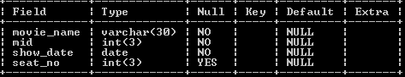

**Table LOGIN:**

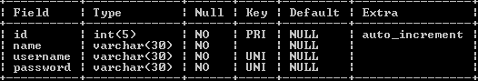

**Table MOVIE:**

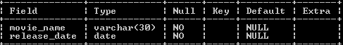

## 

## **6.3 I/O Forms Design & Event Coding:**

The software project for TICKET BOOKING SYSTEM contains various forms along with programming codes. Forms (JFrames) and their event coding are given below.

1.LOGIN FRAME

import java.util.Calendar;

import java.awt.HeadlessException;

import java.sql.*;

import javax.swing.*;

public class NewJFrame1 extends javax.swing.JFrame {

public NewJFrame1() {

initComponents();

}

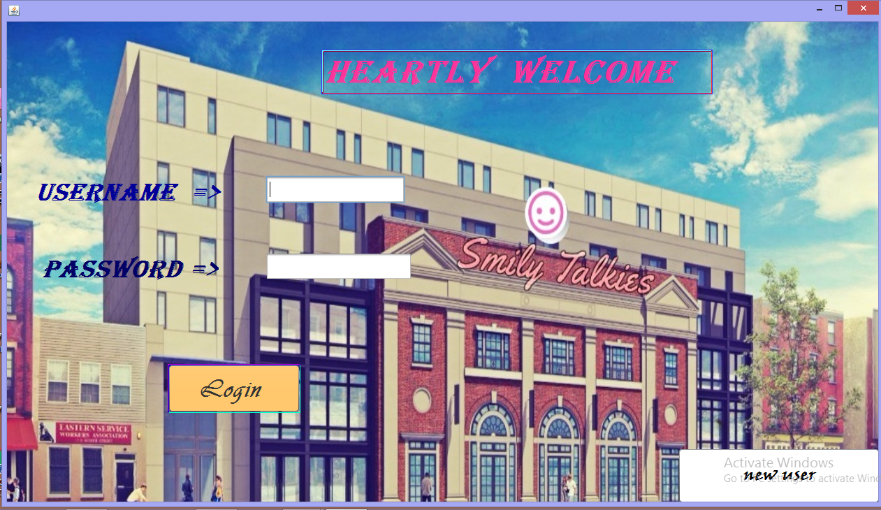

@SuppressWarnings("unchecked")

private void initComponents() {

jPanel1 = new javax.swing.JPanel();

jLabel1 = new javax.swing.JLabel();

jTextField1 = new javax.swing.JTextField();

jButton1 = new javax.swing.JButton();

jButton2 = new javax.swing.JButton();

jTextField2 = new javax.swing.JPasswordField();

usernamel = new javax.swing.JLabel();

passwordl = new javax.swing.JLabel();

jLabel2 = new javax.swing.JLabel();

setDefaultCloseOperation(javax.swing.WindowConstants.EXIT_ON_CLOSE);

setBackground(new java.awt.Color(204, 255, 204));

setForeground(new java.awt.Color(255, 153, 255));

jPanel1.setLayout(null);

jLabel1.setBackground(new java.awt.Color(255, 102, 153));

jLabel1.setFont(new java.awt.Font("Algerian", 3, 48)); // NOI18N

jLabel1.setForeground(new java.awt.Color(255, 51, 153));

jLabel1.setText("heartly welcome ");

jLabel1.setBorder(javax.swing.BorderFactory.createCompoundBorder(javax.swing.BorderFactory.createMatteBorder(1, 1, 1, 1, new java.awt.Color(51, 51, 255)), new javax.swing.border.SoftBevelBorder(javax.swing.border.BevelBorder.RAISED, new java.awt.Color(102, 255, 255), new java.awt.Color(153, 0, 51), new java.awt.Color(255, 51, 51), new java.awt.Color(204, 255, 204))));

jPanel1.add(jLabel1);

jLabel1.setBounds(450, 40, 560, 64);

jTextField1.setFont(new java.awt.Font("Arial", 1, 18)); // NOI18N

jTextField1.addActionListener(new java.awt.event.ActionListener() {

public void actionPerformed(java.awt.event.ActionEvent evt) {

jTextField1ActionPerformed(evt);

}

});

jPanel1.add(jTextField1);

jTextField1.setBounds(370, 220, 200, 40);

jButton1.setBackground(new java.awt.Color(255, 193, 91));

jButton1.setFont(new java.awt.Font("Vivaldi", 1, 36)); // NOI18N

jButton1.setForeground(new java.awt.Color(51, 51, 51));

jButton1.setText("Login ");

jButton1.setBorder(new javax.swing.border.SoftBevelBorder(javax.swing.border.BevelBorder.RAISED, new java.awt.Color(204, 0, 204), new java.awt.Color(0, 0, 204), new java.awt.Color(0, 255, 204), new java.awt.Color(255, 255, 0)));

jButton1.addActionListener(new java.awt.event.ActionListener() {

public void actionPerformed(java.awt.event.ActionEvent evt) {

jButton1ActionPerformed(evt);

}

});

jPanel1.add(jButton1);

jButton1.setBounds(230, 490, 190, 70);

jButton2.setBackground(new java.awt.Color(255, 255, 255));

jButton2.setFont(new java.awt.Font("Viner Hand ITC", 1, 24));

jButton2.setText("new user");

jButton2.addActionListener(new java.awt.event.ActionListener() {

public void actionPerformed(java.awt.event.ActionEvent evt) {

jButton2ActionPerformed(evt);

}

});

jPanel1.add(jButton2);

jButton2.setBounds(960, 610, 290, 80);

jTextField2.setFont(new java.awt.Font("Arial", 1, 18));

jTextField2.addActionListener(new java.awt.event.ActionListener() {

public void actionPerformed(java.awt.event.ActionEvent evt) {

jTextField2ActionPerformed(evt);

}

});

jPanel1.add(jTextField2);

jTextField2.setBounds(370, 330, 210, 40);

usernamel.setFont(new java.awt.Font("Algerian", 3, 36));

usernamel.setForeground(new java.awt.Color(0, 0, 153));

usernamel.setText("Username =>");

jPanel1.add(usernamel);

usernamel.setBounds(40, 220, 270, 48);

passwordl.setFont(new java.awt.Font("Algerian", 3, 36));

passwordl.setForeground(new java.awt.Color(0, 0, 102));

passwordl.setText("password =>");

jPanel1.add(passwordl);

passwordl.setBounds(50, 330, 253, 48);

jLabel2.setIcon(new javax.swing.ImageIcon(getClass().getResource("/Design - Untitled.jpg")));

jLabel2.setMaximumSize(new java.awt.Dimension(1024, 770));

jLabel2.setMinimumSize(new java.awt.Dimension(1024, 700));

jPanel1.add(jLabel2);

jLabel2.setBounds(-110, 0, 1360, 720);

javax.swing.GroupLayout layout = new javax.swing.GroupLayout(getContentPane());

getContentPane().setLayout(layout);

layout.setHorizontalGroup(

layout.createParallelGroup(javax.swing.GroupLayout.Alignment.LEADING)

.addGroup(layout.createSequentialGroup()

.addComponent(jPanel1, javax.swing.GroupLayout.PREFERRED_SIZE, 1247, javax.swing.GroupLayout.PREFERRED_SIZE)

.addGap(0, 0, Short.MAX_VALUE)) );

layout.setVerticalGroup(

layout.createParallelGroup(javax.swing.GroupLayout.Alignment.LEADING)

.addComponent(jPanel1, javax.swing.GroupLayout.PREFERRED_SIZE, 687, javax.swing.GroupLayout.PREFERRED_SIZE) );

pack();

}// </editor-fold>

private void jButton1ActionPerformed(java.awt.event.ActionEvent evt) {

String str1 = jTextField1.getText();

String str2 = new String(jTextField2.getPassword());

if (evt.getSource() == jButton1)

{

try {

Class.forName("com.mysql.jdbc.Driver");

Connection con = (Connection) DriverManager.getConnection("jdbc:mysql://localhost:3306/theatre", "root", "root");

Statement st = con.createStatement();

ResultSet rs = st.executeQuery("select username,password from login");

int tmp=0;

while(rs.next()) {

String val1 = rs.getString(1);

String val2 = rs.getString(2);

if ((val1.equals(str1))&&(val2.equals(str2))) {

this.setVisible(false);

new NewJFrame3().setVisible(true);

tmp++;

} }

if (tmp==0)

{

JOptionPane.showMessageDialog(null, "Username and Password not in database!");

}

rs.close();

st.close();

con.close();

}

catch (Exception e) {

System.out.println(e);

}}}

private void jTextField1ActionPerformed(java.awt.event.ActionEvent evt) { }

private void jTextField2ActionPerformed(java.awt.event.ActionEvent evt) { }

private void jButton2ActionPerformed(java.awt.event.ActionEvent evt) {

this.setVisible(false);

new NewJFrame2().setVisible(true);

}

public static void main(String args[]) {

try {

for (javax.swing.UIManager.LookAndFeelInfo info :

javax.swing.UIManager.getInstalledLookAndFeels()) {

if ("Nimbus".equals(info.getName())) {

javax.swing.UIManager.setLookAndFeel(info.getClassName());

break;

} } } catch (ClassNotFoundException ex) {

java.util.logging.Logger.getLogger(NewJFrame1.class.getName()).log(java.util.logging.Level.SEVERE, null, ex);

} catch (InstantiationException ex) {

java.util.logging.Logger.getLogger(NewJFrame1.class.getName()).log(java.util.logging.Level.SEVERE, null, ex);

} catch (IllegalAccessException ex) {

java.util.logging.Logger.getLogger(NewJFrame1.class.getName()).log(java.util.logging.Level.SEVERE, null, ex);

} catch (javax.swing.UnsupportedLookAndFeelException ex) {

java.util.logging.Logger.getLogger(NewJFrame1.class.getName()).log(java.util.logging.Level.SEVERE, null, ex);

}

java.awt.EventQueue.invokeLater(new Runnable() {

public void run() {

new NewJFrame1().setVisible(true);

} }); }

private javax.swing.JButton jButton1;

private javax.swing.JButton jButton2;

private javax.swing.JLabel jLabel1;

private javax.swing.JLabel jLabel2;

private javax.swing.JPanel jPanel1;

private javax.swing.JTextField jTextField1;

private javax.swing.JPasswordField jTextField2;

private javax.swing.JLabel passwordl;

private javax.swing.JLabel usernamel;

}

2.NEW USER FRAME

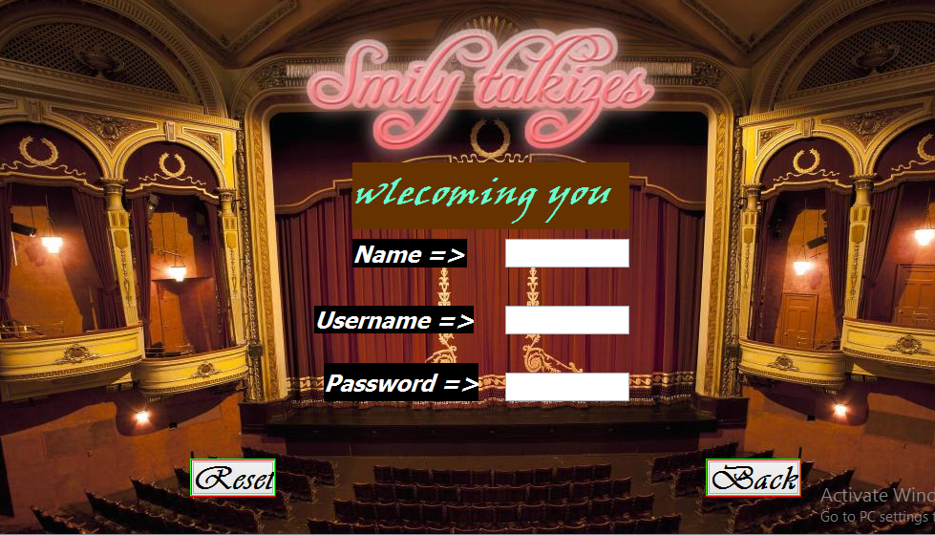

import java.sql.*;

import javax.swing.*;

public class NewJFrame2 extends javax.swing.JFrame {

public NewJFrame2() {

initComponents(); }

@SuppressWarnings("unchecked")

private void initComponents() {

jPanel1 = new javax.swing.JPanel();

jButton1 = new javax.swing.JButton();

jButton3 = new javax.swing.JButton();

jLabel1 = new javax.swing.JLabel();

jLabel2 = new javax.swing.JLabel();

jLabel3 = new javax.swing.JLabel();

jLabel4 = new javax.swing.JLabel();

txt1 = new javax.swing.JTextField();

txt2 = new javax.swing.JTextField();

txt3 = new javax.swing.JPasswordField();

jButton2 = new javax.swing.JButton();

jLabel5 = new javax.swing.JLabel();

setDefaultCloseOperation(javax.swing.WindowConstants.EXIT_ON_CLOSE);

jPanel1.setLayout(null);

jButton1.setFont(new java.awt.Font("Vivaldi", 3, 36));

jButton1.setText("Submit");

jButton1.setBorder(javax.swing.BorderFactory.createEtchedBorder(new java.awt.Color(255, 0, 0), new java.awt.Color(0, 255, 0)));

jButton1.addActionListener(new java.awt.event.ActionListener() {

public void actionPerformed(java.awt.event.ActionEvent evt) {

jButton1ActionPerformed(evt);

} });

jPanel1.add(jButton1);

jButton1.setBounds(470, 580, 130, 40);

jButton3.setFont(new java.awt.Font("Vivaldi", 3, 36)); // NOI18N

jButton3.setText("Back");

jButton3.setBorder(javax.swing.BorderFactory.createEtchedBorder(new java.awt.Color(255, 0, 0), new java.awt.Color(0, 255, 0)));

jButton3.addActionListener(new java.awt.event.ActionListener() {

public void actionPerformed(java.awt.event.ActionEvent evt) {

jButton3ActionPerformed(evt);

} });

jPanel1.add(jButton3);

jButton3.setBounds(740, 480, 100, 40);

jLabel1.setBackground(new java.awt.Color(102, 51, 0));

jLabel1.setFont(new java.awt.Font("Viner Hand ITC", 3, 36));

jLabel1.setForeground(new java.awt.Color(102, 255, 204));

jLabel1.setText("wlecoming you");

jLabel1.setOpaque(true);

jPanel1.add(jLabel1);

jLabel1.setBounds(370, 170, 290, 70);

jLabel2.setBackground(new java.awt.Color(0, 0, 0));

jLabel2.setFont(new java.awt.Font("Tahoma", 3, 24));

jLabel2.setForeground(new java.awt.Color(255, 255, 255));

jLabel2.setText("Name =>");

jLabel2.setOpaque(true);

jPanel1.add(jLabel2);

jLabel2.setBounds(370, 250, 120, 30);

jLabel3.setBackground(new java.awt.Color(0, 0, 0));

jLabel3.setFont(new java.awt.Font("Tahoma", 3, 24));

jLabel3.setForeground(new java.awt.Color(255, 255, 255));

jLabel3.setText("Username =>");

jLabel3.setOpaque(true);

jPanel1.add(jLabel3);

jLabel3.setBounds(330, 320, 167, 29);

jLabel4.setBackground(new java.awt.Color(0, 0, 0));

jLabel4.setFont(new java.awt.Font("Tahoma", 3, 24));

jLabel4.setForeground(new java.awt.Color(255, 255, 255));

jLabel4.setText("Password =>");

jLabel4.setOpaque(true);

jPanel1.add(jLabel4);

jLabel4.setBounds(340, 380, 162, 40);

jPanel1.add(txt1);

txt1.setBounds(530, 250, 130, 30);

jPanel1.add(txt2);

txt2.setBounds(530, 320, 130, 30);

txt3.addActionListener(new java.awt.event.ActionListener() {

public void actionPerformed(java.awt.event.ActionEvent evt) {

txt3ActionPerformed(evt);

} });

jPanel1.add(txt3);

txt3.setBounds(530, 390, 130, 30);

jButton2.setFont(new java.awt.Font("Vivaldi", 3, 36));

jButton2.setText("Reset");

jButton2.setBorder(javax.swing.BorderFactory.createEtchedBorder(new java.awt.Color(255, 0, 0), new java.awt.Color(51, 255, 51)));

jButton2.addActionListener(new java.awt.event.ActionListener() {

public void actionPerformed(java.awt.event.ActionEvent evt) {

jButton2ActionPerformed(evt);

} });

jPanel1.add(jButton2);

jButton2.setBounds(200, 480, 90, 40);

jLabel5.setIcon(new javax.swing.ImageIcon(getClass().getResource("/addtext_com_MjMwNzAyMjQwNTQ.jpg"))); jPanel1.add(jLabel5);

jLabel5.setBounds(0, 0, 1020, 650);

javax.swing.GroupLayout layout = new javax.swing.GroupLayout(getContentPane());

getContentPane().setLayout(layout);

layout.setHorizontalGroup(

layout.createParallelGroup(javax.swing.GroupLayout.Alignment.LEADING)

.addGroup(layout.createSequentialGroup()

.addComponent(jPanel1, javax.swing.GroupLayout.PREFERRED_SIZE, 1016, javax.swing.GroupLayout.PREFERRED_SIZE)

.addGap(0, 2, Short.MAX_VALUE)) );

layout.setVerticalGroup(

layout.createParallelGroup(javax.swing.GroupLayout.Alignment.LEADING)

.addComponent(jPanel1, javax.swing.GroupLayout.PREFERRED_SIZE, 647, javax.swing.GroupLayout.PREFERRED_SIZE) );

pack();

}// </editor-fold>

private void jButton1ActionPerformed(java.awt.event.ActionEvent evt) {

Object n = (String)txt1.getText();

Object un = (String)txt2.getText();

Object pas = new String(txt3.getPassword());

try {

dbcon db = new dbcon();

String query = "INSERT INTO login(name,username,password)"+" VALUES ('"+n+"','"+un+"','"+pas+"')";

db.Executeupdate(query);

JOptionPane.showMessageDialog(this, "now you are eligible.Please login ");

this.setVisible(false);

new NewJFrame1().setVisible(true);

}

catch (Exception e)

{

JOptionPane.showMessageDialog(null, "something went wrong,please retry");

} }

private void jButton2ActionPerformed(java.awt.event.ActionEvent evt) {

txt1.setText("");

txt2.setText("");

txt3.setText("");

}

private void jButton3ActionPerformed(java.awt.event.ActionEvent evt) {

this.setVisible(false);

new NewJFrame1().setVisible(true);

}

private void txt3ActionPerformed(java.awt.event.ActionEvent evt) {

}

public static void main(String args[]) {

try {

for (javax.swing.UIManager.LookAndFeelInfo info : javax.swing.UIManager.getInstalledLookAndFeels()) {

if ("Nimbus".equals(info.getName())) {

javax.swing.UIManager.setLookAndFeel(info.getClassName());

break;

} } } catch (ClassNotFoundException ex) {

java.util.logging.Logger.getLogger(NewJFrame2.class.getName()).log(java.util.logging.Level.SEVERE, null, ex);

} catch (InstantiationException ex) {

java.util.logging.Logger.getLogger(NewJFrame2.class.getName()).log(java.util.logging.Level.SEVERE, null, ex);

} catch (IllegalAccessException ex) {

java.util.logging.Logger.getLogger(NewJFrame2.class.getName()).log(java.util.logging.Level.SEVERE, null, ex);

} catch (javax.swing.UnsupportedLookAndFeelException ex) {

java.util.logging.Logger.getLogger(NewJFrame2.class.getName()).log(java.util.logging.Level.SEVERE, null, ex);

}

java.awt.EventQueue.invokeLater(new Runnable() {

public void run() {

new NewJFrame2().setVisible(true);

} }); }

// Variables declaration - do not modify

private javax.swing.JButton jButton1;

private javax.swing.JButton jButton2;

private javax.swing.JButton jButton3;

private javax.swing.JLabel jLabel1;

private javax.swing.JLabel jLabel2;

private javax.swing.JLabel jLabel3;

private javax.swing.JLabel jLabel4;

private javax.swing.JLabel jLabel5;

private javax.swing.JPanel jPanel1;

private javax.swing.JTextField txt1;

private javax.swing.JTextField txt2;

private javax.swing.JPasswordField txt3;

}

3.MAIN FRAME

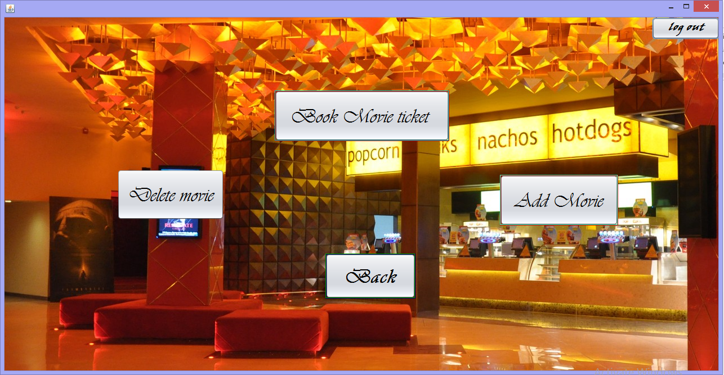public class NewJFrame3 extends javax.swing.JFrame {

public NewJFrame3() {

initComponents();

}

@SuppressWarnings("unchecked")

private void initComponents() {

jButton3 = new javax.swing.JButton();

jPanel1 = new javax.swing.JPanel();

jButton5 = new javax.swing.JButton();

jButton4 = new javax.swing.JButton();

jButton1 = new javax.swing.JButton();

jButton2 = new javax.swing.JButton();

jButton6 = new javax.swing.JButton();

jLabel1 = new javax.swing.JLabel();

jButton3.setText("jButton3");

setDefaultCloseOperation(javax.swing.WindowConstants.EXIT_ON_CLOSE);

jPanel1.setLayout(null);

jButton5.setFont(new java.awt.Font("Vivaldi", 2, 36)); // NOI18N

jButton5.setText("Delete movie");

jButton5.addActionListener(new java.awt.event.ActionListener() {

public void actionPerformed(java.awt.event.ActionEvent evt) {

jButton5ActionPerformed(evt);

} });

jPanel1.add(jButton5);

jButton5.setBounds(200, 270, 190, 90);

jButton4.setFont(new java.awt.Font("Vivaldi", 3, 36)); // NOI18N

jButton4.setText("Back");

jButton4.setBorder(javax.swing.BorderFactory.createEtchedBorder(new java.awt.Color(0, 0, 102), new java.awt.Color(0, 153, 0)));

jButton4.addActionListener(new java.awt.event.ActionListener() {

public void actionPerformed(java.awt.event.ActionEvent evt) {

jButton4ActionPerformed(evt);

} });

jPanel1.add(jButton4);

jButton4.setBounds(570, 420, 160, 80);

jButton1.setFont(new java.awt.Font("Vivaldi", 2, 36));

jButton1.setText("Book Movie ticket ");

jButton1.setBorder(javax.swing.BorderFactory.createEtchedBorder(new java.awt.Color(204, 0, 0), new java.awt.Color(0, 204, 204)));

jButton1.addActionListener(new java.awt.event.ActionListener() {

public void actionPerformed(java.awt.event.ActionEvent evt) {

jButton1ActionPerformed(evt);

} });

jPanel1.add(jButton1);

jButton1.setBounds(480, 130, 310, 90);

jButton2.setFont(new java.awt.Font("Vivaldi", 2, 36));

jButton2.setText("Add Movie");

jButton2.setBorder(javax.swing.BorderFactory.createEtchedBorder(new java.awt.Color(204, 0, 0), new java.awt.Color(51, 255, 204)));

jButton2.addActionListener(new java.awt.event.ActionListener() {

public void actionPerformed(java.awt.event.ActionEvent evt) {

jButton2ActionPerformed(evt);

} });

jPanel1.add(jButton2);

jButton2.setBounds(880, 280, 210, 90);

jButton6.setFont(new java.awt.Font("Viner Hand ITC", 3, 18)); // NOI18N

jButton6.setText("log out");

jButton6.addActionListener(new java.awt.event.ActionListener() {

public void actionPerformed(java.awt.event.ActionEvent evt) {

jButton6ActionPerformed(evt);

} });

jPanel1.add(jButton6);

jButton6.setBounds(1150, 0, 120, 39);

jLabel1.setIcon(new javax.swing.ImageIcon(getClass().getResource("/Lobby-area.jpg"))); // NOI18N

jLabel1.setText("jLabel1");

jPanel1.add(jLabel1);

jLabel1.setBounds(0, 0, 1270, 630);

javax.swing.GroupLayout layout = new javax.swing.GroupLayout(getContentPane());

getContentPane().setLayout(layout);

layout.setHorizontalGroup(

layout.createParallelGroup(javax.swing.GroupLayout.Alignment.LEADING)

.addComponent(jPanel1, javax.swing.GroupLayout.PREFERRED_SIZE, 1268, javax.swing.GroupLayout.PREFERRED_SIZE) );

layout.setVerticalGroup(

layout.createParallelGroup(javax.swing.GroupLayout.Alignment.LEADING)

.addComponent(jPanel1, javax.swing.GroupLayout.PREFERRED_SIZE, 628, javax.swing.GroupLayout.PREFERRED_SIZE) );

pack();

}

private void jButton1ActionPerformed(java.awt.event.ActionEvent evt) {

this.setVisible(false);

new NewJFrame4().setVisible(true);

}

private void jButton2ActionPerformed(java.awt.event.ActionEvent evt) {

this.setVisible(false);

new NewJFrame().setVisible(true);

}

private void jButton4ActionPerformed(java.awt.event.ActionEvent evt) {

this.setVisible(false);

new NewJFrame1().setVisible(true);

}

private void jButton5ActionPerformed(java.awt.event.ActionEvent evt) {

this.setVisible(false);

new NewJFrame6().setVisible(true);

}

private void jButton6ActionPerformed(java.awt.event.ActionEvent evt) {

this.setVisible(false);

new log_out().setVisible(true);

}

public static void main(String args[]) {

try {

for (javax.swing.UIManager.LookAndFeelInfo info : javax.swing.UIManager.getInstalledLookAndFeels()) {

if ("Nimbus".equals(info.getName())) {

javax.swing.UIManager.setLookAndFeel(info.getClassName());

break;

} } } catch (ClassNotFoundException ex) {

java.util.logging.Logger.getLogger(NewJFrame3.class.getName()).log(java.util.logging.Level.SEVERE, null, ex);

} catch (InstantiationException ex) {

java.util.logging.Logger.getLogger(NewJFrame3.class.getName()).log(java.util.logging.Level.SEVERE, null, ex);

} catch (IllegalAccessException ex) {

java.util.logging.Logger.getLogger(NewJFrame3.class.getName()).log(java.util.logging.Level.SEVERE, null, ex);

} catch (javax.swing.UnsupportedLookAndFeelException ex) {

java.util.logging.Logger.getLogger(NewJFrame3.class.getName()).log(java.util.logging.Level.SEVERE, null, ex);

}

java.awt.EventQueue.invokeLater(new Runnable() {

public void run() {

new NewJFrame3().setVisible(true);

} }); }

private javax.swing.JButton jButton1;

private javax.swing.JButton jButton2;

private javax.swing.JButton jButton3;

private javax.swing.JButton jButton4;

private javax.swing.JButton jButton5;

private javax.swing.JButton jButton6;

private javax.swing.JLabel jLabel1;

private javax.swing.JPanel jPanel1;

}

4.TICKETBOOKING FRAME

import java.util.Calendar;

import java.awt.HeadlessException;

import java.sql.*;

import javax.swing.*;

import java.awt.Color;

import java.util.logging.Level;

import java.util.logging.Logger;

public class NewJFrame4 extends javax.swing.JFrame {

public NewJFrame4() {

initComponents();

}

@SuppressWarnings("unchecked")

private void initComponents() {

jPanel1 = new javax.swing.JPanel();

jButton2 = new javax.swing.JButton();

bbb = new com.toedter.calendar.JDateChooser();

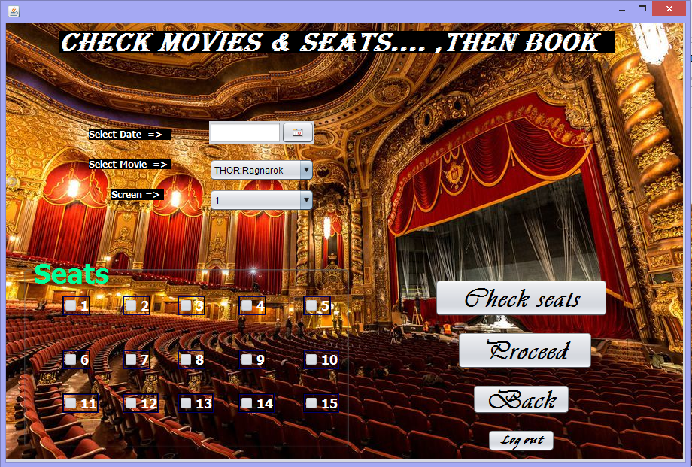

jButton1 = new javax.swing.JButton();

jLabel2 = new javax.swing.JLabel();

jLabel4 = new javax.swing.JLabel();

ccc = new javax.swing.JComboBox<>();

sss = new javax.swing.JLabel();

aaa = new javax.swing.JComboBox<>();

jButton4 = new javax.swing.JButton();

jLabel1 = new javax.swing.JLabel();

jLabel6 = new javax.swing.JLabel();

jPanel2 = new javax.swing.JPanel();

c1 = new javax.swing.JCheckBox();

c11 = new javax.swing.JCheckBox();

c14 = new javax.swing.JCheckBox();

c8 = new javax.swing.JCheckBox();

c10 = new javax.swing.JCheckBox();

c12 = new javax.swing.JCheckBox();

c6 = new javax.swing.JCheckBox();

c4 = new javax.swing.JCheckBox();

c15 = new javax.swing.JCheckBox();

c7 = new javax.swing.JCheckBox();

c3 = new javax.swing.JCheckBox();

c13 = new javax.swing.JCheckBox();

c9 = new javax.swing.JCheckBox();

c5 = new javax.swing.JCheckBox();

c2 = new javax.swing.JCheckBox();

jButton3 = new javax.swing.JButton();

jScrollPane1 = new javax.swing.JScrollPane();

jLabel5 = new javax.swing.JLabel();

jLabel3 = new javax.swing.JLabel();

jTextArea1 = new javax.swing.JTextArea();

jTextField1 = new javax.swing.JTextField();

setDefaultCloseOperation(javax.swing.WindowConstants.EXIT_ON_CLOSE);

addWindowListener(new java.awt.event.WindowAdapter() {

public void windowOpened(java.awt.event.WindowEvent evt) {

formWindowOpened(evt);

} });

jPanel1.setLayout(null);

jButton2.setFont(new java.awt.Font("Vivaldi", 3, 36));

jButton2.setText("Back");

jButton2.addActionListener(new java.awt.event.ActionListener() {

public void actionPerformed(java.awt.event.ActionEvent evt) {

jButton2ActionPerformed(evt);

} });

jPanel1.add(jButton2);

jButton2.setBounds(620, 480, 130, 40);

bbb.setDateFormatString("yyyy-MM-dd");

jPanel1.add(bbb);

bbb.setBounds(270, 130, 140, 30);

jButton1.setFont(new java.awt.Font("Vivaldi", 3, 36)); // NOI18N

jButton1.setText("Check seats");

jButton1.addActionListener(new java.awt.event.ActionListener() {

public void actionPerformed(java.awt.event.ActionEvent evt) {

jButton1ActionPerformed(evt);

}

});

jPanel1.add(jButton1);

jButton1.setBounds(570, 340, 230, 50);

jLabel2.setBackground(new java.awt.Color(0, 0, 0));

jLabel2.setFont(new java.awt.Font("Tahoma", 1, 12)); // NOI18N

jLabel2.setForeground(new java.awt.Color(255, 255, 255));

jLabel2.setText("Select Date =>");

jLabel2.setOpaque(true);

jPanel1.add(jLabel2);

jLabel2.setBounds(110, 140, 110, 15);

jLabel4.setBackground(new java.awt.Color(0, 0, 0));

jLabel4.setFont(new java.awt.Font("Tahoma", 1, 12)); // NOI18N

jLabel4.setForeground(new java.awt.Color(255, 255, 255));

jLabel4.setText("Screen =>");

jLabel4.setOpaque(true);

jPanel1.add(jLabel4);

jLabel4.setBounds(140, 220, 70, 15);

ccc.setModel(new javax.swing.DefaultComboBoxModel<>(new String[] { "1", "2", "3" }));

jPanel1.add(ccc);

ccc.setBounds(270, 220, 140, 30);

jPanel1.add(sss);

sss.setBounds(0, 0, 0, 0);

aaa.setModel(new javax.swing.DefaultComboBoxModel<>(new String[] { "twilight", "spiderman", "avenger" }));

aaa.addMouseListener(new java.awt.event.MouseAdapter() {

public void mouseClicked(java.awt.event.MouseEvent evt) {

aaaMouseClicked(evt);

} });

aaa.addActionListener(new java.awt.event.ActionListener() {

public void actionPerformed(java.awt.event.ActionEvent evt) {

aaaActionPerformed(evt);

} });

jPanel1.add(aaa);

aaa.setBounds(270, 180, 140, 30);

jButton4.setFont(new java.awt.Font("Vivaldi", 3, 36)); // NOI18N

jButton4.setText("Proceed");

jButton4.addActionListener(new java.awt.event.ActionListener() {

public void actionPerformed(java.awt.event.ActionEvent evt) {

jButton4ActionPerformed(evt);

} });

jPanel1.add(jButton4);

jButton4.setBounds(600, 410, 180, 50);

jLabel1.setBackground(new java.awt.Color(0, 0, 0));

jLabel1.setFont(new java.awt.Font("Tahoma", 1, 12)); // NOI18N

jLabel1.setForeground(new java.awt.Color(255, 255, 255));

jLabel1.setText("Select Movie =>");

jLabel1.setOpaque(true);

jPanel1.add(jLabel1);

jLabel1.setBounds(110, 180, 110, 14);

jLabel6.setBackground(new java.awt.Color(0, 0, 0));

jLabel6.setFont(new java.awt.Font("Algerian", 3, 36)); // NOI18N

jLabel6.setForeground(new java.awt.Color(255, 255, 255));

jLabel6.setText("check movies & seats.... ,then book");

jLabel6.setOpaque(true);

jPanel1.add(jLabel6);

jLabel6.setBounds(70, 10, 740, 30);

jPanel2.setBorder(javax.swing.BorderFactory.createTitledBorder(null, "Seats\n\n", javax.swing.border.TitledBorder.LEFT, javax.swing.border.TitledBorder.TOP, new java.awt.Font("Tahoma", 1, 36), new java.awt.Color(0, 255, 153))); // NOI18N

jPanel2.setOpaque(false);

c1.setBackground(java.awt.Color.green);

c1.setFont(new java.awt.Font("Tahoma", 1, 18)); // NOI18N

c1.setForeground(new java.awt.Color(255, 255, 255));

c1.setText("1");

c1.setBorder(javax.swing.BorderFactory.createEtchedBorder(javax.swing.border.EtchedBorder.RAISED, new java.awt.Color(0, 0, 0), new java.awt.Color(0, 0, 102)));

c1.setBorderPainted(true);

c1.setEnabled(false);

c1.setOpaque(false);

c11.setBackground(java.awt.Color.green);

c11.setFont(new java.awt.Font("Tahoma", 1, 18)); // NOI18N

c11.setForeground(new java.awt.Color(255, 255, 255));

c11.setText("11");

c11.setBorder(javax.swing.BorderFactory.createEtchedBorder(javax.swing.border.EtchedBorder.RAISED, new java.awt.Color(0, 0, 0), new java.awt.Color(0, 0, 102)));

c11.setBorderPainted(true);

c11.setEnabled(false);

c11.setOpaque(false);

c14.setBackground(java.awt.Color.green);

c14.setFont(new java.awt.Font("Tahoma", 1, 18)); // NOI18N

c14.setForeground(new java.awt.Color(255, 255, 255));

c14.setText("14");

c14.setBorder(javax.swing.BorderFactory.createEtchedBorder(javax.swing.border.EtchedBorder.RAISED, new java.awt.Color(0, 0, 0), new java.awt.Color(0, 0, 102)));

c14.setBorderPainted(true);

c14.setEnabled(false);

c14.setOpaque(false);

c8.setBackground(java.awt.Color.green);

c8.setFont(new java.awt.Font("Tahoma", 1, 18)); // NOI18N

c8.setForeground(new java.awt.Color(255, 255, 255));

c8.setText("8");

c8.setBorder(javax.swing.BorderFactory.createEtchedBorder(javax.swing.border.EtchedBorder.RAISED, new java.awt.Color(0, 0, 0), new java.awt.Color(0, 0, 102)));

c8.setBorderPainted(true);

c8.setEnabled(false);

c8.setOpaque(false);

c10.setBackground(java.awt.Color.green);

c10.setFont(new java.awt.Font("Tahoma", 1, 18)); // NOI18N

c10.setForeground(new java.awt.Color(255, 255, 255));

c10.setText("10");

c10.setBorder(javax.swing.BorderFactory.createEtchedBorder(javax.swing.border.EtchedBorder.RAISED, new java.awt.Color(0, 0, 0), new java.awt.Color(0, 0, 102)));

c10.setBorderPainted(true);

c10.setEnabled(false);

c10.setOpaque(false);

c12.setBackground(java.awt.Color.green);

c12.setFont(new java.awt.Font("Tahoma", 1, 18)); // NOI18N

c12.setForeground(new java.awt.Color(255, 255, 255));

c12.setText("12");

c12.setBorder(javax.swing.BorderFactory.createEtchedBorder(javax.swing.border.EtchedBorder.RAISED, new java.awt.Color(0, 0, 0), new java.awt.Color(0, 0, 102)));

c12.setBorderPainted(true);

c12.setEnabled(false);

c12.setOpaque(false);

c12.addActionListener(new java.awt.event.ActionListener() {

public void actionPerformed(java.awt.event.ActionEvent evt) {

c12ActionPerformed(evt);

} });

c6.setBackground(java.awt.Color.green);

c6.setFont(new java.awt.Font("Tahoma", 1, 18)); // NOI18N

c6.setForeground(new java.awt.Color(255, 255, 255));

c6.setText("6");

c6.setBorder(javax.swing.BorderFactory.createEtchedBorder(javax.swing.border.EtchedBorder.RAISED, new java.awt.Color(0, 0, 0), new java.awt.Color(0, 0, 102)));

c6.setBorderPainted(true);

c6.setEnabled(false);

c6.setOpaque(false);

c4.setBackground(java.awt.Color.green);

c4.setFont(new java.awt.Font("Tahoma", 1, 18)); // NOI18N

c4.setForeground(new java.awt.Color(255, 255, 255));

c4.setText("4");

c4.setBorder(javax.swing.BorderFactory.createEtchedBorder(javax.swing.border.EtchedBorder.RAISED, new java.awt.Color(0, 0, 0), new java.awt.Color(0, 0, 102)));

c4.setBorderPainted(true);

c4.setEnabled(false);

c4.setOpaque(false);

c15.setBackground(java.awt.Color.green);

c15.setFont(new java.awt.Font("Tahoma", 1, 18)); // NOI18N

c15.setForeground(new java.awt.Color(255, 255, 255));

c15.setText("15");

c15.setBorder(javax.swing.BorderFactory.createEtchedBorder(javax.swing.border.EtchedBorder.RAISED, new java.awt.Color(0, 0, 0), new java.awt.Color(0, 0, 102)));

c15.setBorderPainted(true);

c15.setEnabled(false);

c15.setOpaque(false);

c7.setBackground(java.awt.Color.green);

c7.setFont(new java.awt.Font("Tahoma", 1, 18)); // NOI18N

c7.setForeground(new java.awt.Color(255, 255, 255));

c7.setText("7");

c7.setBorder(javax.swing.BorderFactory.createEtchedBorder(javax.swing.border.EtchedBorder.RAISED, new java.awt.Color(0, 0, 0), new java.awt.Color(0, 0, 102)));

c7.setBorderPainted(true);

c7.setEnabled(false);

c7.setOpaque(false);

c7.addActionListener(new java.awt.event.ActionListener() {

public void actionPerformed(java.awt.event.ActionEvent evt) {

c7ActionPerformed(evt);

} });

c3.setBackground(java.awt.Color.green);

c3.setFont(new java.awt.Font("Tahoma", 1, 18)); // NOI18N

c3.setForeground(new java.awt.Color(255, 255, 255));

c3.setText("3");

c3.setBorder(javax.swing.BorderFactory.createEtchedBorder(javax.swing.border.EtchedBorder.RAISED, new java.awt.Color(0, 0, 0), new java.awt.Color(0, 0, 102)));

c3.setBorderPainted(true);

c3.setEnabled(false);

c3.setOpaque(false);

c3.addActionListener(new java.awt.event.ActionListener() {

public void actionPerformed(java.awt.event.ActionEvent evt) {

c3ActionPerformed(evt);

} });

c13.setBackground(java.awt.Color.green);

c13.setFont(new java.awt.Font("Tahoma", 1, 18)); // NOI18N

c13.setForeground(new java.awt.Color(255, 255, 255));

c13.setText("13");

c13.setBorder(javax.swing.BorderFactory.createEtchedBorder(javax.swing.border.EtchedBorder.RAISED, new java.awt.Color(0, 0, 0), new java.awt.Color(0, 0, 102)));

c13.setBorderPainted(true);

c13.setEnabled(false);

c13.setOpaque(false);

c13.addActionListener(new java.awt.event.ActionListener() {

public void actionPerformed(java.awt.event.ActionEvent evt) {

c13ActionPerformed(evt);

} });

c9.setBackground(java.awt.Color.green);

c9.setFont(new java.awt.Font("Tahoma", 1, 18)); // NOI18N

c9.setForeground(new java.awt.Color(255, 255, 255));

c9.setText("9");

c9.setBorder(javax.swing.BorderFactory.createEtchedBorder(javax.swing.border.EtchedBorder.RAISED, new java.awt.Color(0, 0, 0), new java.awt.Color(0, 0, 102)));

c9.setBorderPainted(true);

c9.setEnabled(false);

c9.setOpaque(false);

c5.setBackground(java.awt.Color.green);

c5.setFont(new java.awt.Font("Tahoma", 1, 18)); // NOI18N

c5.setForeground(new java.awt.Color(255, 255, 255));

c5.setText("5");

c5.setBorder(javax.swing.BorderFactory.createEtchedBorder(javax.swing.border.EtchedBorder.RAISED, new java.awt.Color(0, 0, 0), new java.awt.Color(0, 0, 102)));

c5.setBorderPainted(true);

c5.setEnabled(false);

c5.setOpaque(false);

c2.setBackground(java.awt.Color.green);

c2.setFont(new java.awt.Font("Tahoma", 1, 18)); // NOI18N

c2.setForeground(new java.awt.Color(255, 255, 255));

c2.setText("2");

c2.setBorder(javax.swing.BorderFactory.createEtchedBorder(javax.swing.border.EtchedBorder.RAISED, new java.awt.Color(0, 0, 0), new java.awt.Color(0, 0, 102)));

c2.setBorderPainted(true);

c2.setEnabled(false);

c2.setOpaque(false);

javax.swing.GroupLayout jPanel2Layout = new javax.swing.GroupLayout(jPanel2);

jPanel2.setLayout(jPanel2Layout);

jPanel2Layout.setHorizontalGroup(

jPanel2Layout.createParallelGroup(javax.swing.GroupLayout.Alignment.LEADING)

.addGroup(jPanel2Layout.createSequentialGroup()

.addGap(41, 41, 41)

.addGroup(jPanel2Layout.createParallelGroup(javax.swing.GroupLayout.Alignment.LEADING)

.addGroup(jPanel2Layout.createParallelGroup(javax.swing.GroupLayout.Alignment.TRAILING)

.addComponent(c6, javax.swing.GroupLayout.Alignment.LEADING)

.addComponent(c1))

.addComponent(c11))

.addGap(32, 32, 32)

.addGroup(jPanel2Layout.createParallelGroup(javax.swing.GroupLayout.Alignment.LEADING)

.addGroup(jPanel2Layout.createSequentialGroup()

.addGroup(jPanel2Layout.createParallelGroup(javax.swing.GroupLayout.Alignment.LEADING)

.addComponent(c2)

.addComponent(c7))

.addGap(36, 36, 36)

.addGroup(jPanel2Layout.createParallelGroup(javax.swing.GroupLayout.Alignment.LEADING)

.addComponent(c13)

.addGroup(jPanel2Layout.createParallelGroup(javax.swing.GroupLayout.Alignment.TRAILING)

.addComponent(c8)

.addComponent(c3))))

.addComponent(c12))

.addGap(33, 33, 33)

.addGroup(jPanel2Layout.createParallelGroup(javax.swing.GroupLayout.Alignment.LEADING)

.addGroup(jPanel2Layout.createParallelGroup(javax.swing.GroupLayout.Alignment.TRAILING)

.addComponent(c4)

.addComponent(c9, javax.swing.GroupLayout.Alignment.LEADING))

.addComponent(c14))

.addGap(38, 38, 38)

.addGroup(jPanel2Layout.createParallelGroup(javax.swing.GroupLayout.Alignment.LEADING)

.addComponent(c15)

.addComponent(c5)

.addComponent(c10))

.addContainerGap(43, Short.MAX_VALUE)) );

jPanel2Layout.setVerticalGroup(

jPanel2Layout.createParallelGroup(javax.swing.GroupLayout.Alignment.LEADING)

.addGroup(jPanel2Layout.createSequentialGroup()

.addContainerGap()

.addGroup(jPanel2Layout.createParallelGroup(javax.swing.GroupLayout.Alignment.BASELINE)

.addComponent(c1)

.addComponent(c2)

.addComponent(c3)

.addComponent(c4)

.addComponent(c5))

.addGap(46, 46, 46)

.addGroup(jPanel2Layout.createParallelGroup(javax.swing.GroupLayout.Alignment.BASELINE)

.addComponent(c10)

.addComponent(c9)

.addComponent(c8)

.addComponent(c7)

.addComponent(c6))

.addPreferredGap(javax.swing.LayoutStyle.ComponentPlacement.RELATED, 31,Short.MAX_VALUE)

.addGroup(jPanel2Layout.createParallelGroup(javax.swing.GroupLayout.Alignment.BASELINE)

.addComponent(c11)

.addComponent(c12)

.addComponent(c13)

.addComponent(c14)

.addComponent(c15))

.addGap(38, 38, 38)) );

jPanel1.add(jPanel2);

jPanel2.setBounds(20, 310, 440, 260);

jButton3.setFont(new java.awt.Font("Viner Hand ITC", 3, 14)); // NOI18N

jButton3.setText("Log out");

jButton3.addActionListener(new java.awt.event.ActionListener() {

public void actionPerformed(java.awt.event.ActionEvent evt) {

jButton3ActionPerformed(evt);

} });

jPanel1.add(jButton3);

jButton3.setBounds(640, 540, 90, 30);

jPanel1.add(jScrollPane1);

jScrollPane1.setBounds(590, 200, 2, 2);

jLabel5.setIcon(new javax.swing.ImageIcon(getClass().getResource("/_MG_5462.0.jpg")));

jPanel1.add(jLabel5);

jLabel5.setBounds(0, -30, 900, 620);

jLabel3.setBackground(new java.awt.Color(0, 0, 0));

jLabel3.setFont(new java.awt.Font("Tahoma", 1, 12)); // NOI18N

jLabel3.setForeground(new java.awt.Color(255, 255, 255));

jLabel3.setText("seats");

jLabel3.setOpaque(true);

jPanel1.add(jLabel3);

jLabel3.setBounds(800, 170, 90, 20);

jTextArea1.setColumns(20);

jTextArea1.setRows(5);

jPanel1.add(jTextArea1);

jTextArea1.setBounds(0, 0, 164, 94);

jTextField1.setText("jTextField1");

jPanel1.add(jTextField1);

jTextField1.setBounds(700, 200, 59, 20);

javax.swing.GroupLayout layout = new javax.swing.GroupLayout(getContentPane());

getContentPane().setLayout(layout);

layout.setHorizontalGroup(

layout.createParallelGroup(javax.swing.GroupLayout.Alignment.LEADING)

.addComponent(jPanel1, javax.swing.GroupLayout.PREFERRED_SIZE, 903, javax.swing.GroupLayout.PREFERRED_SIZE) );

layout.setVerticalGroup(

layout.createParallelGroup(javax.swing.GroupLayout.Alignment.LEADING)

.addComponent(jPanel1, javax.swing.GroupLayout.PREFERRED_SIZE, 584, javax.swing.GroupLayout.PREFERRED_SIZE) );

pack();

}// </editor-fold>

private void aaaActionPerformed(java.awt.event.ActionEvent evt) { }

private void jButton1ActionPerformed(java.awt.event.ActionEvent evt) {

{

c1.setOpaque(rootPaneCheckingEnabled);

c1.setBackground(Color.green);

c2.setOpaque(rootPaneCheckingEnabled);

c2.setBackground(Color.green);

c3.setOpaque(rootPaneCheckingEnabled);

c3.setBackground(Color.green);

c4.setOpaque(rootPaneCheckingEnabled);

c4.setBackground(Color.green);

c5.setOpaque(rootPaneCheckingEnabled);

c5.setBackground(Color.green);

c6.setOpaque(rootPaneCheckingEnabled);

c6.setBackground(Color.green);

c7.setOpaque(rootPaneCheckingEnabled);

c7.setBackground(Color.green);

c8.setOpaque(rootPaneCheckingEnabled);

c8.setBackground(Color.green);

c9.setOpaque(rootPaneCheckingEnabled);

c9.setBackground(Color.green);

c10.setOpaque(rootPaneCheckingEnabled);

c10.setBackground(Color.green);

c11.setOpaque(rootPaneCheckingEnabled);

c11.setBackground(Color.green);

c12.setOpaque(rootPaneCheckingEnabled);

c12.setBackground(Color.green);

c13.setOpaque(rootPaneCheckingEnabled);

c13.setBackground(Color.green);

c14.setOpaque(rootPaneCheckingEnabled);

c14.setBackground(Color.green);

c15.setOpaque(rootPaneCheckingEnabled);

c15.setBackground(Color.green);

c1.setEnabled(rootPaneCheckingEnabled);

c2.setEnabled(rootPaneCheckingEnabled);

c3.setEnabled(rootPaneCheckingEnabled);

c4.setEnabled(rootPaneCheckingEnabled);

c5.setEnabled(rootPaneCheckingEnabled);

c6.setEnabled(rootPaneCheckingEnabled);

c7.setEnabled(rootPaneCheckingEnabled);

c8.setEnabled(rootPaneCheckingEnabled);

c9.setEnabled(rootPaneCheckingEnabled);

c10.setEnabled(rootPaneCheckingEnabled);

c11.setEnabled(rootPaneCheckingEnabled);

c12.setEnabled(rootPaneCheckingEnabled);

c13.setEnabled(rootPaneCheckingEnabled);

c14.setEnabled(rootPaneCheckingEnabled);

c15.setEnabled(rootPaneCheckingEnabled);

Object str1 = aaa.getSelectedItem();

Object str2 = ccc.getSelectedItem();

Object date = (((JTextField)bbb.getDateEditor().getUiComponent()).getText());

int a=0,b=0,c=0,d=0,e=0,f=0,g=0,h=0,i=0,j=0,k=0,l=0,m=0,n=0,o=0;

if (evt.getSource() == jButton1)

{

try {

Class.forName("com.mysql.jdbc.Driver");

Connection con = (Connection) DriverManager.getConnection("jdbc:mysql://localhost:3306/theatre", "root", "root");

Statement st = con.createStatement();

ResultSet rs = st.executeQuery("select movie_name,mid,show_date,seat_no from booking ");

while (rs.next()) {

{

String val1 = rs.getString(1);

String val2 = rs.getString(2);

String val3 = rs.getString(3);

String val5 = rs.getString(4);

if ((val1.equals(str1))&&(val2.equals(str2)))

{ if (val3.equals(date))

{ if (val5.equals("1"))

{ c1.setEnabled(false);

c1.setBackground(Color.red);

a =1; }

else if(val5.equals("2"))

{ c2.setEnabled(false);

c2.setBackground(Color.red);

b=1; }

else if(val5.equals("3"))

{ c3.setEnabled(false);

c3.setBackground(Color.red);

c=1; }

else if(val5.equals("4"))

{ c4.setEnabled(false);

c4.setBackground(Color.red);

d =1; }

else if(val5.equals("5"))

{ c5.setEnabled(false);

c5.setBackground(Color.red);

e=1; }

else if(val5.equals("6"))

{ c6.setEnabled(false);

c6.setBackground(Color.red);

f=1; }

else if(val5.equals("7"))

{ c7.setEnabled(false);

c7.setBackground(Color.red);

g=1; }

else if(val5.equals("8"))

{ c8.setEnabled(false);

c8.setBackground(Color.red);

h=1; }

else if(val5.equals("9"))

{ c9.setEnabled(false);

c9.setBackground(Color.red);

i=1; }

else if(val5.equals("10"))

{ c10.setEnabled(false);

c10.setBackground(Color.red);

j=1; }

else if(val5.equals("11"))

{ c11.setEnabled(false);

c11.setBackground(Color.red);

k=1; }

else if(val5.equals("13"))

{ c13.setEnabled(false);

c13.setBackground(Color.red);

l=1; }

else if(val5.equals("14"))

{ c14.setEnabled(false);

c14.setBackground(Color.red);

m=1; }

else if(val5.equals("15"))

{ c15.setEnabled(false);

c15.setBackground(Color.red);

n=1; }

else if(val5.equals("12"))

{ c12.setEnabled(false);

c12.setBackground(Color.red);

o=1; } } } } }

int su = a+b+c+d+e+f+g+h+i+j+k+l+m+n;

sss.setText(""+su);

rs.close();

st.close();

con.close(); }

catch (SQLException ex) {

System.out.print("exception is" + ex); }

catch (ClassNotFoundException ex) {

System.out.print("exception is" + ex);

} } } }

private void jButton2ActionPerformed(java.awt.event.ActionEvent evt) {

// TODO add your handling code here:

this.setVisible(false);

new NewJFrame3().setVisible(true); }

private void c13ActionPerformed(java.awt.event.ActionEvent evt) { }

private void c3ActionPerformed(java.awt.event.ActionEvent evt) { }

private void c7ActionPerformed(java.awt.event.ActionEvent evt) { }

private void c12ActionPerformed(java.awt.event.ActionEvent evt) { }

private void jButton4ActionPerformed(java.awt.event.ActionEvent evt) {

String str1 = (String) aaa.getSelectedItem();

String str2 = (String)ccc.getSelectedItem();

String date = (String)(((JTextField)bbb.getDateEditor().getUiComponent()).getText());

int a=0,b=0,c=0,d=0,e=0,f=0,g=0,h=0,i=0,j=0,k=0,l=0,m=0,n=0,o=0;

String a2="",a3="",a4="",a5="",a6="",a7="",a8="",a9="",a10="",a11="",a12="",a13="",a14="",a15="",a1 ="";

if(c1.isSelected()==true)

{ a=1;a1 = "1"; jTextArea1.append(a1+" "); }

if(c2.isSelected()==true)

{ b=1;a2="2"; jTextArea1.append(a2+" "); }

if(c3.isSelected()==true)

{ c=1;a3="3"; jTextArea1.append(a3+" "); }

if(c4.isSelected()==true)

{ d=1;a4="4"; jTextArea1.append(a4+" "); }

if(c5.isSelected()==true)

{ e=1;a5="5"; jTextArea1.append(a5+" "); }

if(c6.isSelected()==true)

{ f=1;a6="6"; jTextArea1.append(a6+" "); }

if(c7.isSelected()==true)

{ g=1;a7="7"; jTextArea1.append(a7+" "); }

if(c8.isSelected()==true)

{ h=1;a8="8"; jTextArea1.append(a8+" "); }

if(c9.isSelected()==true)

{ i=1;a9="9";jTextArea1.append(a9+" "); }

if(c10.isSelected()==true)

{ j=1;a10="10";jTextArea1.append(a10+" "); }

if(c11.isSelected()==true)

{ k=1;a11="11";jTextArea1.append(a11+" "); }

if(c12.isSelected()==true)

{ l=1;a12="12";jTextArea1.append(a12+" "); }

if(c13.isSelected()==true)

{ m=1;a13="13";jTextArea1.append(a13+" "); }

if(c14.isSelected()==true)

{ n=1;a14="14";jTextArea1.append(a14+" "); }

if(c15.isSelected()==true)

{ o=1;a15="15";jTextArea1.append(a15+" "); }

String aa = (a+b+c+d+e+f+g+h+i+j+k+l+m+n+o+"");

String qq = jTextArea1.getText();

this.setVisible(false);

new NewJFrame5(str1,str2,date,aa,qq).setVisible(true);

}

private void jButton3ActionPerformed(java.awt.event.ActionEvent evt) {

this.setVisible(false);

new log_out().setVisible(true);

}

private void formWindowOpened(java.awt.event.WindowEvent evt) {

try {

Class.forName("com.mysql.jdbc.Driver");

Connection con = (Connection) DriverManager.getConnection("jdbc:mysql://localhost:3306/theatre", "root", "root");

Statement st = con.createStatement();

ResultSet rs = st.executeQuery("select movie_name from movie");

aaa.removeAllItems();

while (rs.next())

{

String val1 = rs.getString(1);

aaa.addItem(val1); }

rs.close();

st.close();

con.close(); }

catch (Exception e)

{ JOptionPane.showMessageDialog(null,"a..."); } }

private void aaaMouseClicked(java.awt.event.MouseEvent evt) { }

public static void main(String args[]) {

try {

for (javax.swing.UIManager.LookAndFeelInfo info : javax.swing.UIManager.getInstalledLookAndFeels()) {

if ("Nimbus".equals(info.getName())) {

javax.swing.UIManager.setLookAndFeel(info.getClassName());

break; } } }

catch (ClassNotFoundException ex) {

java.util.logging.Logger.getLogger(NewJFrame4.class.getName()).log(java.util.logging.Level.SEVERE, null, ex);

} catch (InstantiationException ex) {

java.util.logging.Logger.getLogger(NewJFrame4.class.getName()).log(java.util.logging.Level.SEVERE, null, ex);

} catch (IllegalAccessException ex) {

java.util.logging.Logger.getLogger(NewJFrame4.class.getName()).log(java.util.logging.Level.SEVERE, null, ex);

} catch (javax.swing.UnsupportedLookAndFeelException ex) {

java.util.logging.Logger.getLogger(NewJFrame4.class.getName()).log(java.util.logging.Level.SEVERE, null, ex);

}

java.awt.EventQueue.invokeLater(new Runnable() {

public void run() {

new NewJFrame4().setVisible(true);

} }); }

private javax.swing.JComboBox<String> aaa;

private com.toedter.calendar.JDateChooser bbb;

private javax.swing.JCheckBox c1;

private javax.swing.JCheckBox c10;

private javax.swing.JCheckBox c11;

private javax.swing.JCheckBox c12;

private javax.swing.JCheckBox c13;

private javax.swing.JCheckBox c14;

private javax.swing.JCheckBox c15;

private javax.swing.JCheckBox c2;

private javax.swing.JCheckBox c3;

private javax.swing.JCheckBox c4;

private javax.swing.JCheckBox c5;

private javax.swing.JCheckBox c6;

private javax.swing.JCheckBox c7;

private javax.swing.JCheckBox c8;

private javax.swing.JCheckBox c9;

private javax.swing.JComboBox<String> ccc;

private javax.swing.JButton jButton1;

private javax.swing.JButton jButton2;

private javax.swing.JButton jButton3;

private javax.swing.JButton jButton4;

private javax.swing.JLabel jLabel1;

private javax.swing.JLabel jLabel2;

private javax.swing.JLabel jLabel3;

private javax.swing.JLabel jLabel4;

private javax.swing.JLabel jLabel5;

private javax.swing.JLabel jLabel6;

private javax.swing.JPanel jPanel1;

private javax.swing.JPanel jPanel2;

private javax.swing.JScrollPane jScrollPane1;

private javax.swing.JTextArea jTextArea1;

private javax.swing.JTextField jTextField1;

private javax.swing.JLabel sss;

}

5. ADDMOVIE FRAME

import java.sql.*;

import javax.swing.*;

import java.util.logging.Level;

import java.util.logging.Logger;

import java.util.Calendar;

import java.awt.HeadlessException;

public class NewJFrame extends javax.swing.JFrame {

public NewJFrame() {

initComponents(); }

@SuppressWarnings("unchecked")

private void initComponents() {

jPanel1 = new javax.swing.JPanel();

jLabel1 = new javax.swing.JLabel();

jButton1 = new javax.swing.JButton();

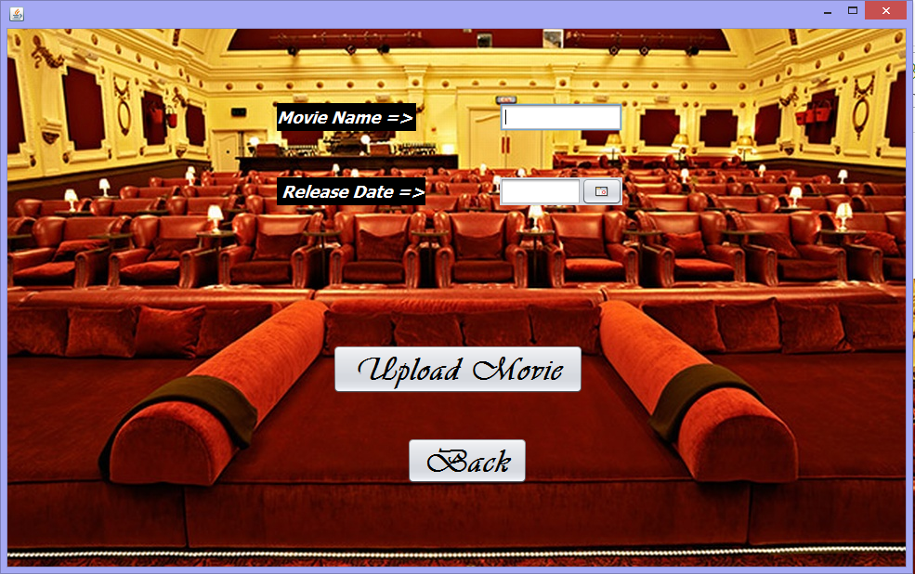

jButton2 = new javax.swing.JButton();

jLabel2 = new javax.swing.JLabel();

jTextField1 = new javax.swing.JTextField();

date = new com.toedter.calendar.JDateChooser();

jLabel4 = new javax.swing.JLabel();

setDefaultCloseOperation(javax.swing.WindowConstants.EXIT_ON_CLOSE);

jPanel1.setLayout(null);

jLabel1.setBackground(new java.awt.Color(0, 0, 0));

jLabel1.setFont(new java.awt.Font("Tahoma", 3, 18)); // NOI18N

jLabel1.setForeground(new java.awt.Color(255, 255, 255));

jLabel1.setText("Movie Name =>");

jLabel1.setOpaque(true);

jPanel1.add(jLabel1);

jLabel1.setBounds(290, 80, 150, 30);

jButton1.setFont(new java.awt.Font("Vivaldi", 3, 36)); // NOI18N

jButton1.setText("Upload Movie");

jButton1.addActionListener(new java.awt.event.ActionListener() {

public void actionPerformed(java.awt.event.ActionEvent evt) {

jButton1ActionPerformed(evt); } });

jPanel1.add(jButton1);

jButton1.setBounds(350, 340, 270, 53);

jButton2.setFont(new java.awt.Font("Vivaldi", 3, 36)); // NOI18N

jButton2.setText("Back");

jButton2.addActionListener(new java.awt.event.ActionListener() {

public void actionPerformed(java.awt.event.ActionEvent evt) {

jButton2ActionPerformed(evt); } });

jPanel1.add(jButton2);

jButton2.setBounds(430, 440, 130, 50);

jLabel2.setBackground(new java.awt.Color(0, 0, 0));

jLabel2.setFont(new java.awt.Font("Tahoma", 3, 18)); // NOI18N

jLabel2.setForeground(new java.awt.Color(255, 255, 255));

jLabel2.setText(" Release Date =>");

jLabel2.setOpaque(true);

jPanel1.add(jLabel2);

jLabel2.setBounds(290, 160, 160, 30);

jTextField1.addActionListener(new java.awt.event.ActionListener() {

public void actionPerformed(java.awt.event.ActionEvent evt) {

jTextField1ActionPerformed(evt); } });

jPanel1.add(jTextField1);

jTextField1.setBounds(530, 80, 132, 30);

date.setDateFormatString("yyyy-MM-dd");

jPanel1.add(date);

date.setBounds(530, 160, 132, 30);

jLabel4.setIcon(new javax.swing.ImageIcon(getClass().getResource("/electric_cinema_london.jpg")));

jPanel1.add(jLabel4);

jLabel4.setBounds(0, 0, 970, 580);

javax.swing.GroupLayout layout = new javax.swing.GroupLayout(getContentPane());

getContentPane().setLayout(layout);

layout.setHorizontalGroup(

layout.createParallelGroup(javax.swing.GroupLayout.Alignment.LEADING)

.addComponent(jPanel1, javax.swing.GroupLayout.PREFERRED_SIZE, 967, javax.swing.GroupLayout.PREFERRED_SIZE) );

layout.setVerticalGroup(

layout.createParallelGroup(javax.swing.GroupLayout.Alignment.LEADING)

.addComponent(jPanel1, javax.swing.GroupLayout.PREFERRED_SIZE, 579, javax.swing.GroupLayout.PREFERRED_SIZE) );

pack();

}// </editor-fold>

private void jButton1ActionPerformed(java.awt.event.ActionEvent evt) {

String str1 = (String)jTextField1.getText();

Object str2 = (((JTextField)date.getDateEditor().getUiComponent()).getText());

try {

dbcon db = new dbcon();

String query = "INSERT INTO movie(movie_name,release_date)"+" VALUES ('"+str1+"','"+str2+"')";

db.Executeupdate(query);

JOptionPane.showMessageDialog(this, "movie successfully uploaded");

this.setVisible(false);

new NewJFrame3().setVisible(true);

}

catch (Exception e) {

JOptionPane.showMessageDialog(null, "something went wrong,please retry");

} }

private void jButton2ActionPerformed(java.awt.event.ActionEvent evt) {

this.setVisible(false);

new NewJFrame3().setVisible(true);

}

private void jTextField1ActionPerformed(java.awt.event.ActionEvent evt) { }

public static void main(String args[]) {

try {

for (javax.swing.UIManager.LookAndFeelInfo info : javax.swing.UIManager.getInstalledLookAndFeels()) {

if ("Nimbus".equals(info.getName())) {

javax.swing.UIManager.setLookAndFeel(info.getClassName());

break;

} } }

catch (ClassNotFoundException ex) {

java.util.logging.Logger.getLogger(NewJFrame.class.getName()).log(java.util.logging.Level.SEVERE, null, ex);

} catch (InstantiationException ex) {

java.util.logging.Logger.getLogger(NewJFrame.class.getName()).log(java.util.logging.Level.SEVERE, null, ex);

} catch (IllegalAccessException ex) {

java.util.logging.Logger.getLogger(NewJFrame.class.getName()).log(java.util.logging.Level.SEVERE, null, ex);

} catch (javax.swing.UnsupportedLookAndFeelException ex) {

java.util.logging.Logger.getLogger(NewJFrame.class.getName()).log(java.util.logging.Level.SEVERE, null, ex); }

java.awt.EventQueue.invokeLater(new Runnable() {

public void run() {

new NewJFrame().setVisible(true);

} }); }

private com.toedter.calendar.JDateChooser date;

private javax.swing.JButton jButton1;

private javax.swing.JButton jButton2;

private javax.swing.JLabel jLabel1;

private javax.swing.JLabel jLabel2;

private javax.swing.JLabel jLabel4;

private javax.swing.JPanel jPanel1;

private javax.swing.JTextField jTextField1;

private void executeQuery(String query1) {

throw new UnsupportedOperationException("Not supported yet.");

}

6.MOVIE DELETER FRAME

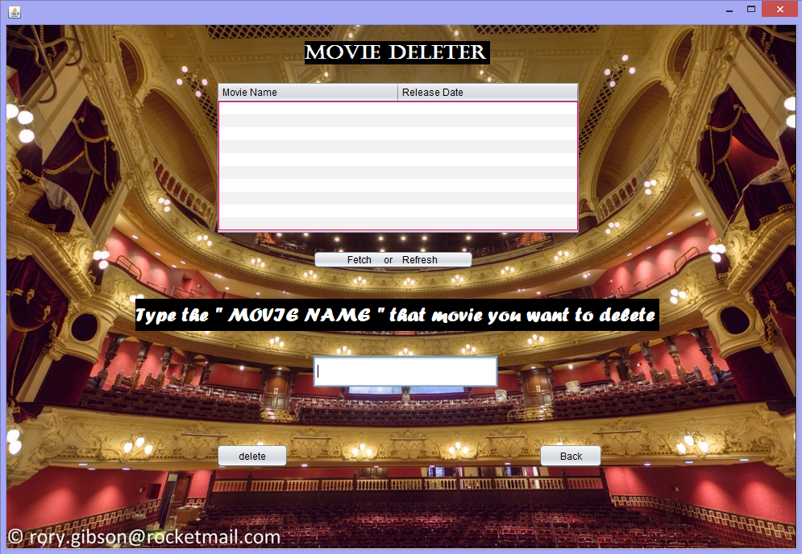

import java.sql.*;

import javax.swing.*;

import javax.swing.table.DefaultTableModel;

import javax.swing.table.TableModel;

public class NewJFrame6 extends javax.swing.JFrame {

public NewJFrame6() {

initComponents(); }

@SuppressWarnings("unchecked")

private void initComponents() {

jScrollPane1 = new javax.swing.JScrollPane();

jTable1 = new javax.swing.JTable();

jPanel1 = new javax.swing.JPanel();

jButton3 = new javax.swing.JButton();

jButton1 = new javax.swing.JButton();

jLabel1 = new javax.swing.JLabel();

jScrollPane2 = new javax.swing.JScrollPane();

jTable2 = new javax.swing.JTable();

jButton2 = new javax.swing.JButton();

jTextField1 = new javax.swing.JTextField();

jLabel2 = new javax.swing.JLabel();

jLabel3 = new javax.swing.JLabel();

jTable1.setModel(new javax.swing.table.DefaultTableModel(

new Object [][] {

{null, null, null, null},

{null, null, null, null},

{null, null, null, null},

{null, null, null, null} },

new String [] {

"Title 1", "Title 2", "Title 3", "Title 4" } ));

jScrollPane1.setViewportView(jTable1);

setDefaultCloseOperation(javax.swing.WindowConstants.EXIT_ON_CLOSE);

jPanel1.setLayout(null);

jButton3.setText("Back");

jButton3.addActionListener(new java.awt.event.ActionListener() {

public void actionPerformed(java.awt.event.ActionEvent evt) {

jButton3ActionPerformed(evt); } });

jPanel1.add(jButton3);

jButton3.setBounds(660, 520, 80, 30);

jButton1.setText("Fetch or Refresh ");

jButton1.addActionListener(new java.awt.event.ActionListener() {

public void actionPerformed(java.awt.event.ActionEvent evt) {

jButton1ActionPerformed(evt);

} });

jPanel1.add(jButton1);

jButton1.setBounds(380, 280, 200, 23);

jLabel1.setBackground(new java.awt.Color(0, 0, 0));

jLabel1.setFont(new java.awt.Font("Forte", 1, 24)); // NOI18N

jLabel1.setForeground(new java.awt.Color(255, 255, 255));

jLabel1.setText("Type the \" MOVIE NAME \" that movie you want to delete");

jLabel1.setOpaque(true);

jPanel1.add(jLabel1);

jLabel1.setBounds(160, 340, 650, 40);

jTable2.setBorder(javax.swing.BorderFactory.createMatteBorder(1, 1, 1, 1, new java.awt.Color(255, 0, 102)));

jTable2.setModel(new javax.swing.table.DefaultTableModel(

new Object [][] {

{null, null},

{null, null},

{null, null},

{null, null},

{null, null},

{null, null},

{null, null},

{null, null},

{null, null},

{null, null}

},

new String [] { "Movie Name ", "Release Date" }

) {

Class[] types = new Class [] {

java.lang.Object.class, java.lang.Integer.class };

public Class getColumnClass(int columnIndex) {

return types [columnIndex];

} });

jScrollPane2.setViewportView(jTable2);

jPanel1.add(jScrollPane2);

jScrollPane2.setBounds(260, 70, 452, 190);

jButton2.setText("delete");

jButton2.addActionListener(new java.awt.event.ActionListener() {

public void actionPerformed(java.awt.event.ActionEvent evt) {

jButton2ActionPerformed(evt);

} });

jPanel1.add(jButton2);

jButton2.setBounds(260, 520, 90, 30);

jPanel1.add(jTextField1);

jTextField1.setBounds(380, 410, 230, 40);

jLabel2.setBackground(new java.awt.Color(0, 0, 0));

jLabel2.setFont(new java.awt.Font("Castellar", 1, 24)); // NOI18N

jLabel2.setForeground(new java.awt.Color(255, 255, 255));

jLabel2.setText("Movie deleter");

jLabel2.setOpaque(true);

jPanel1.add(jLabel2);

jLabel2.setBounds(370, 20, 230, 29);

jLabel3.setIcon(new javax.swing.ImageIcon(getClass().getResource("/1265934_After_Restoration___Newcastle_Theatre_Royal__Credit_Rory_Gibson.jpg"))); // NOI18N

jPanel1.add(jLabel3);

jLabel3.setBounds(0, 0, 980, 650);

javax.swing.GroupLayout layout = new javax.swing.GroupLayout(getContentPane());

getContentPane().setLayout(layout);

layout.setHorizontalGroup(

layout.createParallelGroup(javax.swing.GroupLayout.Alignment.LEADING)

.addComponent(jPanel1, javax.swing.GroupLayout.Alignment.TRAILING, javax.swing.GroupLayout.DEFAULT_SIZE, 981, Short.MAX_VALUE)

);

layout.setVerticalGroup(

layout.createParallelGroup(javax.swing.GroupLayout.Alignment.LEADING)

.addComponent(jPanel1, javax.swing.GroupLayout.PREFERRED_SIZE, 651, javax.swing.GroupLayout.PREFERRED_SIZE) );

pack();

}// </editor-fold>

private void jButton1ActionPerformed(java.awt.event.ActionEvent evt) {

try {

Class.forName("com.mysql.jdbc.Driver");

Connection con = (Connection) DriverManager.getConnection("jdbc:mysql://localhost:3306/theatre", "root", "root");

Statement st = con.createStatement();

String query = "select * from movie";

ResultSet rs = st.executeQuery(query);

String mn; Object rd; int m;

DefaultTableModel tm;

tm = (DefaultTableModel)jTable2.getModel();

if(jTable2.getRowCount()>0)

{ for(int i=jTable2.getRowCount()-1;i>-1;i--) {

tm.removeRow(i);

} }

while (rs.next()) {

mn = rs.getString(1);

m = rs.getInt(2);

rd = rs.getString(3);

tm.addRow(new Object[] {mn,m,rd}); }

rs.close();

st.close();

con.close(); }

catch (Exception e) {

JOptionPane.showMessageDialog(null, "something went wrong,please retry");

} }

private void jButton2ActionPerformed(java.awt.event.ActionEvent evt) {

String i = jTextField1.getText();

try {

Class.forName("com.mysql.jdbc.Driver");

Connection con = (Connection) DriverManager.getConnection("jdbc:mysql://localhost:3306/theatre", "root", "root");

Statement st = con.createStatement();

String query = "delete from movie where movie_name = '"+i+"' ";

st.executeUpdate(query);

st.close();

con.close(); }

catch (Exception e) {

JOptionPane.showMessageDialog(null, "something went wrong,please retry");

} }

private void jButton3ActionPerformed(java.awt.event.ActionEvent evt) {

this.setVisible(false);

new NewJFrame3().setVisible(true); }

public static void main(String args[]) {

try {

for (javax.swing.UIManager.LookAndFeelInfo info : javax.swing.UIManager.getInstalledLookAndFeels()) {

if ("Nimbus".equals(info.getName())) {

javax.swing.UIManager.setLookAndFeel(info.getClassName());

break; } }

} catch (ClassNotFoundException ex) {

java.util.logging.Logger.getLogger(NewJFrame6.class.getName()).log(java.util.logging.Level.SEVERE, null, ex);

} catch (InstantiationException ex) {

java.util.logging.Logger.getLogger(NewJFrame6.class.getName()).log(java.util.logging.Level.SEVERE, null, ex);

} catch (IllegalAccessException ex) {

java.util.logging.Logger.getLogger(NewJFrame6.class.getName()).log(java.util.logging.Level.SEVERE, null, ex);

} catch (javax.swing.UnsupportedLookAndFeelException ex) {

java.util.logging.Logger.getLogger(NewJFrame6.class.getName()).log(java.util.logging.Level.SEVERE, null, ex);

}

java.awt.EventQueue.invokeLater(new Runnable() {

public void run() {

new NewJFrame6().setVisible(true);

} }); }

private javax.swing.JButton jButton1;

private javax.swing.JButton jButton2;

private javax.swing.JButton jButton3;

private javax.swing.JLabel jLabel1;

private javax.swing.JLabel jLabel2;

private javax.swing.JLabel jLabel3;

private javax.swing.JPanel jPanel1;

private javax.swing.JScrollPane jScrollPane1;

private javax.swing.JScrollPane jScrollPane2;

private javax.swing.JTable jTable1;

private javax.swing.JTable jTable2;

private javax.swing.JTextField jTextField1;

}

7. RECEIPT FRAME

import java.util.Calendar;

import java.awt.HeadlessException;

import java.sql.*;

import javax.swing.*;

import java.awt.Color;

import java.io.BufferedReader;

import java.io.FileReader;

import java.util.logging.Level;

import java.util.logging.Logger;

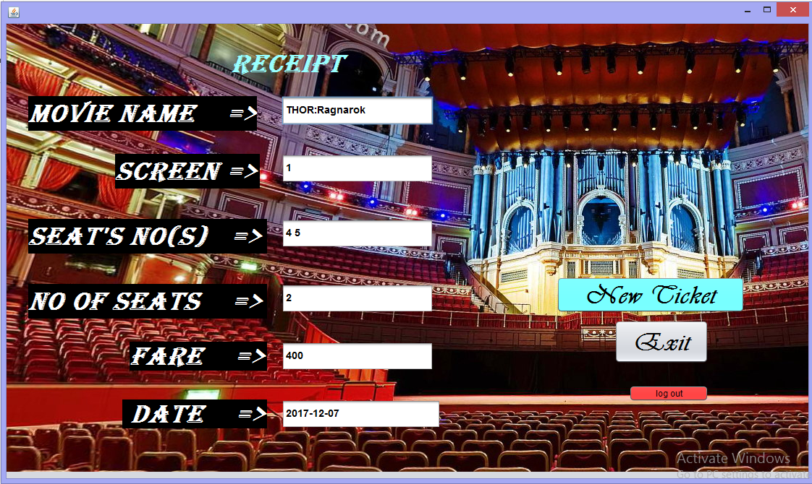

public class NewJFrame5 extends javax.swing.JFrame {

public NewJFrame5() {

initComponents(); }

public NewJFrame5(String str1,String str2,String date,String qq ,String aa) {

initComponents();

jTextField3.setText(qq);

jTextField1.setText(aa);

jTextField2.setText(date);

jTextField5.setText(str2);

jTextField6.setText(str1);

int a = Integer.parseInt(jTextField3.getText());

int f = a*200;

jTextField4.setText(""+f); }

@SuppressWarnings("unchecked")

private void initComponents() {

filler1 = new javax.swing.Box.Filler(new java.awt.Dimension(0, 0), new java.awt.Dimension(0, 0), new java.awt.Dimension(0, 32767));

jPanel2 = new javax.swing.JPanel();

jTextField4 = new javax.swing.JTextField();

jLabel3 = new javax.swing.JLabel();

jLabel6 = new javax.swing.JLabel();

jTextField1 = new javax.swing.JTextField();

jLabel7 = new javax.swing.JLabel();

jButton1 = new javax.swing.JButton();

jTextField2 = new javax.swing.JTextField();

jLabel4 = new javax.swing.JLabel();

jTextField5 = new javax.swing.JTextField();

jTextField3 = new javax.swing.JTextField();

jButton2 = new javax.swing.JButton();

jLabel5 = new javax.swing.JLabel();

jTextField6 = new javax.swing.JTextField();

jLabel2 = new javax.swing.JLabel();

jLabel1 = new javax.swing.JLabel();

jButton3 = new javax.swing.JButton();

jLabel9 = new javax.swing.JLabel();

setDefaultCloseOperation(javax.swing.WindowConstants.EXIT_ON_CLOSE);

addWindowListener(new java.awt.event.WindowAdapter() {

public void windowOpened(java.awt.event.WindowEvent evt) {

formWindowOpened(evt); } });

jPanel2.setLayout(null);

jTextField4.setEditable(false);

jTextField4.setFont(new java.awt.Font("Arial", 1, 14)); // NOI18N

jTextField4.addActionListener(new java.awt.event.ActionListener() {

public void actionPerformed(java.awt.event.ActionEvent evt) {

jTextField4ActionPerformed(evt); } });

jPanel2.add(jTextField4);

jTextField4.setBounds(380, 440, 210, 40);

jLabel3.setBackground(new java.awt.Color(0, 0, 0));

jLabel3.setFont(new java.awt.Font("Algerian", 3, 36)); // NOI18N

jLabel3.setForeground(new java.awt.Color(255, 255, 255));

jLabel3.setText("Fare =>");

jLabel3.setOpaque(true);

jPanel2.add(jLabel3);

jLabel3.setBounds(170, 440, 190, 40);

jLabel6.setBackground(new java.awt.Color(0, 0, 0));

jLabel6.setFont(new java.awt.Font("Algerian", 3, 36)); // NOI18N

jLabel6.setForeground(new java.awt.Color(255, 255, 255));

jLabel6.setText("seat's no(s) =>");

jLabel6.setOpaque(true);

jPanel2.add(jLabel6);

jLabel6.setBounds(30, 270, 330, 48);

jTextField1.setEditable(false);

jTextField1.setFont(new java.awt.Font("Arial", 1, 14)); // NOI18N

jPanel2.add(jTextField1);

jTextField1.setBounds(380, 270, 210, 40);

jLabel7.setBackground(new java.awt.Color(0, 0, 0));

jLabel7.setFont(new java.awt.Font("Algerian", 3, 36)); // NOI18N

jLabel7.setForeground(new java.awt.Color(255, 255, 255));

jLabel7.setText(" date =>");

jLabel7.setFocusable(false);

jLabel7.setOpaque(true);

jPanel2.add(jLabel7);

jLabel7.setBounds(160, 520, 200, 40);

jButton1.setBackground(new java.awt.Color(102, 255, 255));

jButton1.setFont(new java.awt.Font("Vivaldi", 3, 36)); // NOI18N

jButton1.setText("New Ticket");

jButton1.addActionListener(new java.awt.event.ActionListener() {

public void actionPerformed(java.awt.event.ActionEvent evt) {

jButton1ActionPerformed(evt); } });

jPanel2.add(jButton1);

jButton1.setBounds(760, 350, 260, 50);

jTextField2.setEditable(false);

jTextField2.setFont(new java.awt.Font("Arial", 1, 14)); // NOI18N

jTextField2.addActionListener(new java.awt.event.ActionListener() {

public void actionPerformed(java.awt.event.ActionEvent evt) {

jTextField2ActionPerformed(evt); } });

jPanel2.add(jTextField2);

jTextField2.setBounds(380, 520, 220, 40);

jLabel4.setBackground(new java.awt.Color(0, 0, 0));

jLabel4.setFont(new java.awt.Font("Algerian", 3, 36)); // NOI18N

jLabel4.setForeground(new java.awt.Color(255, 255, 255));

jLabel4.setText("Screen =>");

jLabel4.setOpaque(true);

jPanel2.add(jLabel4);

jLabel4.setBounds(150, 180, 200, 48);

jTextField5.setEditable(false);

jTextField5.setFont(new java.awt.Font("Arial", 1, 14)); // NOI18N

jTextField5.addActionListener(new java.awt.event.ActionListener() {

public void actionPerformed(java.awt.event.ActionEvent evt) {

jTextField5ActionPerformed(evt); } });

jPanel2.add(jTextField5);

jTextField5.setBounds(380, 180, 210, 40);

jTextField3.setEditable(false);

jTextField3.setFont(new java.awt.Font("Arial", 1, 14)); // NOI18N

jPanel2.add(jTextField3);

jTextField3.setBounds(380, 360, 210, 40);

jButton2.setFont(new java.awt.Font("Vivaldi", 3, 36)); // NOI18N

jButton2.setText("Exit");

jButton2.addActionListener(new java.awt.event.ActionListener() {

public void actionPerformed(java.awt.event.ActionEvent evt) {

jButton2ActionPerformed(evt); } });

jPanel2.add(jButton2);

jButton2.setBounds(840, 410, 130, 60);

jLabel5.setBackground(new java.awt.Color(0, 0, 0));

jLabel5.setFont(new java.awt.Font("Algerian", 3, 36)); // NOI18N

jLabel5.setForeground(new java.awt.Color(255, 255, 255));

jLabel5.setText("Movie Name =>");

jLabel5.setOpaque(true);

jPanel2.add(jLabel5);

jLabel5.setBounds(30, 100, 316, 48);

jTextField6.setEditable(false);

jTextField6.setFont(new java.awt.Font("Arial", 1, 14)); // NOI18N

jTextField6.addActionListener(new java.awt.event.ActionListener() {

public void actionPerformed(java.awt.event.ActionEvent evt) {

jTextField6ActionPerformed(evt); } });

jPanel2.add(jTextField6);

jTextField6.setBounds(380, 100, 210, 40);

jLabel2.setBackground(new java.awt.Color(0, 0, 0));

jLabel2.setFont(new java.awt.Font("Algerian", 3, 36)); // NOI18N

jLabel2.setForeground(new java.awt.Color(255, 255, 255));

jLabel2.setText("No of seats =>");

jLabel2.setOpaque(true);

jPanel2.add(jLabel2);

jLabel2.setBounds(30, 360, 330, 48);

jLabel1.setFont(new java.awt.Font("Algerian", 3, 36)); // NOI18N

jLabel1.setForeground(new java.awt.Color(153, 255, 255));

jLabel1.setText("RECEIPT");

jPanel2.add(jLabel1);

jLabel1.setBounds(310, 20, 270, 70);

jButton3.setBackground(new java.awt.Color(255, 51, 51));

jButton3.setText("log out");

jButton3.addActionListener(new java.awt.event.ActionListener() {

public void actionPerformed(java.awt.event.ActionEvent evt) {

jButton3ActionPerformed(evt); } });

jPanel2.add(jButton3);

jButton3.setBounds(860, 500, 110, 23);

jLabel9.setIcon(new javax.swing.ImageIcon(getClass().getResource("/royal-albert-hall-seating-plan-05-arena-b-e-row-15-centre-seats-organ-viewing-experience-high-resolution.jpg"))); // NOI18N

jPanel2.add(jLabel9);

jLabel9.setBounds(0, 0, 1110, 620);

javax.swing.GroupLayout layout = new javax.swing.GroupLayout(getContentPane());

getContentPane().setLayout(layout);

layout.setHorizontalGroup(

layout.createParallelGroup(javax.swing.GroupLayout.Alignment.LEADING)

.addComponent(jPanel2, javax.swing.GroupLayout.DEFAULT_SIZE, 1108, Short.MAX_VALUE) );

layout.setVerticalGroup(

layout.createParallelGroup(javax.swing.GroupLayout.Alignment.LEADING)

.addComponent(jPanel2, javax.swing.GroupLayout.DEFAULT_SIZE, 629, Short.MAX_VALUE) );

pack();

setLocationRelativeTo(null);

}// </editor-fold>

private void jButton2ActionPerformed(java.awt.event.ActionEvent evt) {

this.setVisible(false);

new exit().setVisible(true); }

private void jButton1ActionPerformed(java.awt.event.ActionEvent evt) {

this.setVisible(false);

new NewJFrame7().setVisible(true);

}

private void jTextField5ActionPerformed(java.awt.event.ActionEvent evt) { }

private void jTextField6ActionPerformed(java.awt.event.ActionEvent evt) { }

private void jTextField4ActionPerformed(java.awt.event.ActionEvent evt) { }

private void jTextField2ActionPerformed(java.awt.event.ActionEvent evt) { }

private void jButton3ActionPerformed(java.awt.event.ActionEvent evt) {

this.setVisible(false);

new log_out().setVisible(true); }

private void formWindowOpened(java.awt.event.WindowEvent evt) {

String mn = jTextField6.getText();

String mid = jTextField5.getText();

String date = jTextField2.getText();

String str = jTextField1.getText();

try {

Class.forName("com.mysql.jdbc.Driver");

Connection con = (Connection) DriverManager.getConnection("jdbc:mysql://localhost:3306/theatre", "root", "root");

Statement st = con.createStatement();

String arr[]=str.split(" ");

for (int i=0;i<arr.length;i++){

String query = "INSERT INTO booking VALUES ('"+mn+"','"+mid+"','"+date+"','"+arr[i]+"')";

st.executeUpdate(query);

} }

catch (Exception e) {

JOptionPane.showMessageDialog(null, "something went wrong,please retry");

} }

public static void main(String args[]) {

try {

for (javax.swing.UIManager.LookAndFeelInfo info : javax.swing.UIManager.getInstalledLookAndFeels()) {

if ("Nimbus".equals(info.getName())) {

javax.swing.UIManager.setLookAndFeel(info.getClassName());

break;

} }} catch (ClassNotFoundException ex) {

java.util.logging.Logger.getLogger(NewJFrame5.class.getName()).log(java.util.logging.Level.SEVERE, null, ex);

} catch (InstantiationException ex) {

java.util.logging.Logger.getLogger(NewJFrame5.class.getName()).log(java.util.logging.Level.SEVERE, null, ex);

} catch (IllegalAccessException ex) {

java.util.logging.Logger.getLogger(NewJFrame5.class.getName()).log(java.util.logging.Level.SEVERE, null, ex);

} catch (javax.swing.UnsupportedLookAndFeelException ex) {

java.util.logging.Logger.getLogger(NewJFrame5.class.getName()).log(java.util.logging.Level.SEVERE, null, ex);

}

java.awt.EventQueue.invokeLater(new Runnable() {

public void run() {

new NewJFrame5().setVisible(true);

} }); }

private javax.swing.Box.Filler filler1;

private javax.swing.JButton jButton1;

private javax.swing.JButton jButton2;

private javax.swing.JButton jButton3;

private javax.swing.JLabel jLabel1;

private javax.swing.JLabel jLabel2;

private javax.swing.JLabel jLabel3;

private javax.swing.JLabel jLabel4;

private javax.swing.JLabel jLabel5;

private javax.swing.JLabel jLabel6;

private javax.swing.JLabel jLabel7;

private javax.swing.JLabel jLabel9;

private javax.swing.JPanel jPanel2;

private javax.swing.JTextField jTextField1;

private javax.swing.JTextField jTextField2;

private javax.swing.JTextField jTextField3;

private javax.swing.JTextField jTextField4;

private javax.swing.JTextField jTextField5;

private javax.swing.JTextField jTextField6;

}At end of project if we logout , new ticket or exit the receipt frame a thought is displayed on j frame.

**7. User Manual**

## 7.1 How to installSoftware:

### **Hardware Requirement-**

* Intel Pentium/Celeron or similar processor based PC at Client/Server end.
* 128 MB RAM and 4GB HDD space (for Database) is desirable.
* Standard I/O devices like Keyboard and Mouse etc.
* Printer is needed for hard-copy reports.
* Local Area Network(LAN) is required for Client-Server Installation

### **Software Requirement-**

* Windows 2000/XP OS is desirable.
* NetBeans Ver 5.1 or higher should be installed with JDK and JVM.
* MySQL Ver 6.1 with Quizdb Database must be present at machine.

### **Database Installation**

The software project is distributed with a backup copy of a Database named **Theatrebookingsystemdb** with required tables. Some dummy records are present in the tables for testing purposes, which can be deleted before inserting real data. The project is shipped with **Theatrebookingsystem.SQL** file which installs a database and tables in the computer system.

Note: The PC must have MySQL server with user (***root***) and password (***raj***) . If root password is any other password, it can be changed by running MySQL Server Instance Configure Wizard.

Start ⏵Program ⏵ MySQL ⏵MySQL Server ⏵MySQL Server Instance Config Wizard Provide current password of root and new password as “sjat” , this will change the root password.

To install a MySQL database from a dump file ***(*Quiz*.sql)*** , simply follow the following steps.

**Step 1:** Copy the **Quiz**.sql file in **C:\Program files\Mysql\MySql server 5.1\Bin** folder.

**Step 2:** Open MySQL and type the following command to create the dabase named **Quizdb**.

mysql> create database **Quizdb**;

**Step 3:** Open Command Window (Start ⏵Run ⏵ cmd)

**Step 4:** Go to the following folder using CD command of DOS.

**C:\Program files\Mysql\MySql server 5.1\Bin>**

**Step 5:** type the following command on above prompt -

**C:….\bin>** mysql -u ***root*** -p***raj*** Quizdb < Quiz.sql

This will create a Quizdb databse with required tables.

## 

**8. References**

In order to work on this project titled -***THEATRE BOOKING SYSTEM,*** the following books and literature are refered by me during the various phases of development of the project.

(1) The Complete Reference Java 2.0

-by Shildit

1. MySQL, Black Book

-by Steven Holzner

(2) Understanding SQL

– Gruber

(3) <http://www.mysql.org/>

(4) <http://www.netbeans.org>/

(5) <http://www.w3school.com>/

(6) Informatics Practices for class XII

-by Sumita Arora

(7) Together with Informatics Practices

(6) Various Websites of Discussion Forum and software development activities.

Other than the above-mentioned books, the suggestions and supervision of my teacher and my class experience also helped me to develop this software project.